**The Temple University Hospital EEG Corpus:**

**Annotation Guidelines**

June 1, 2020

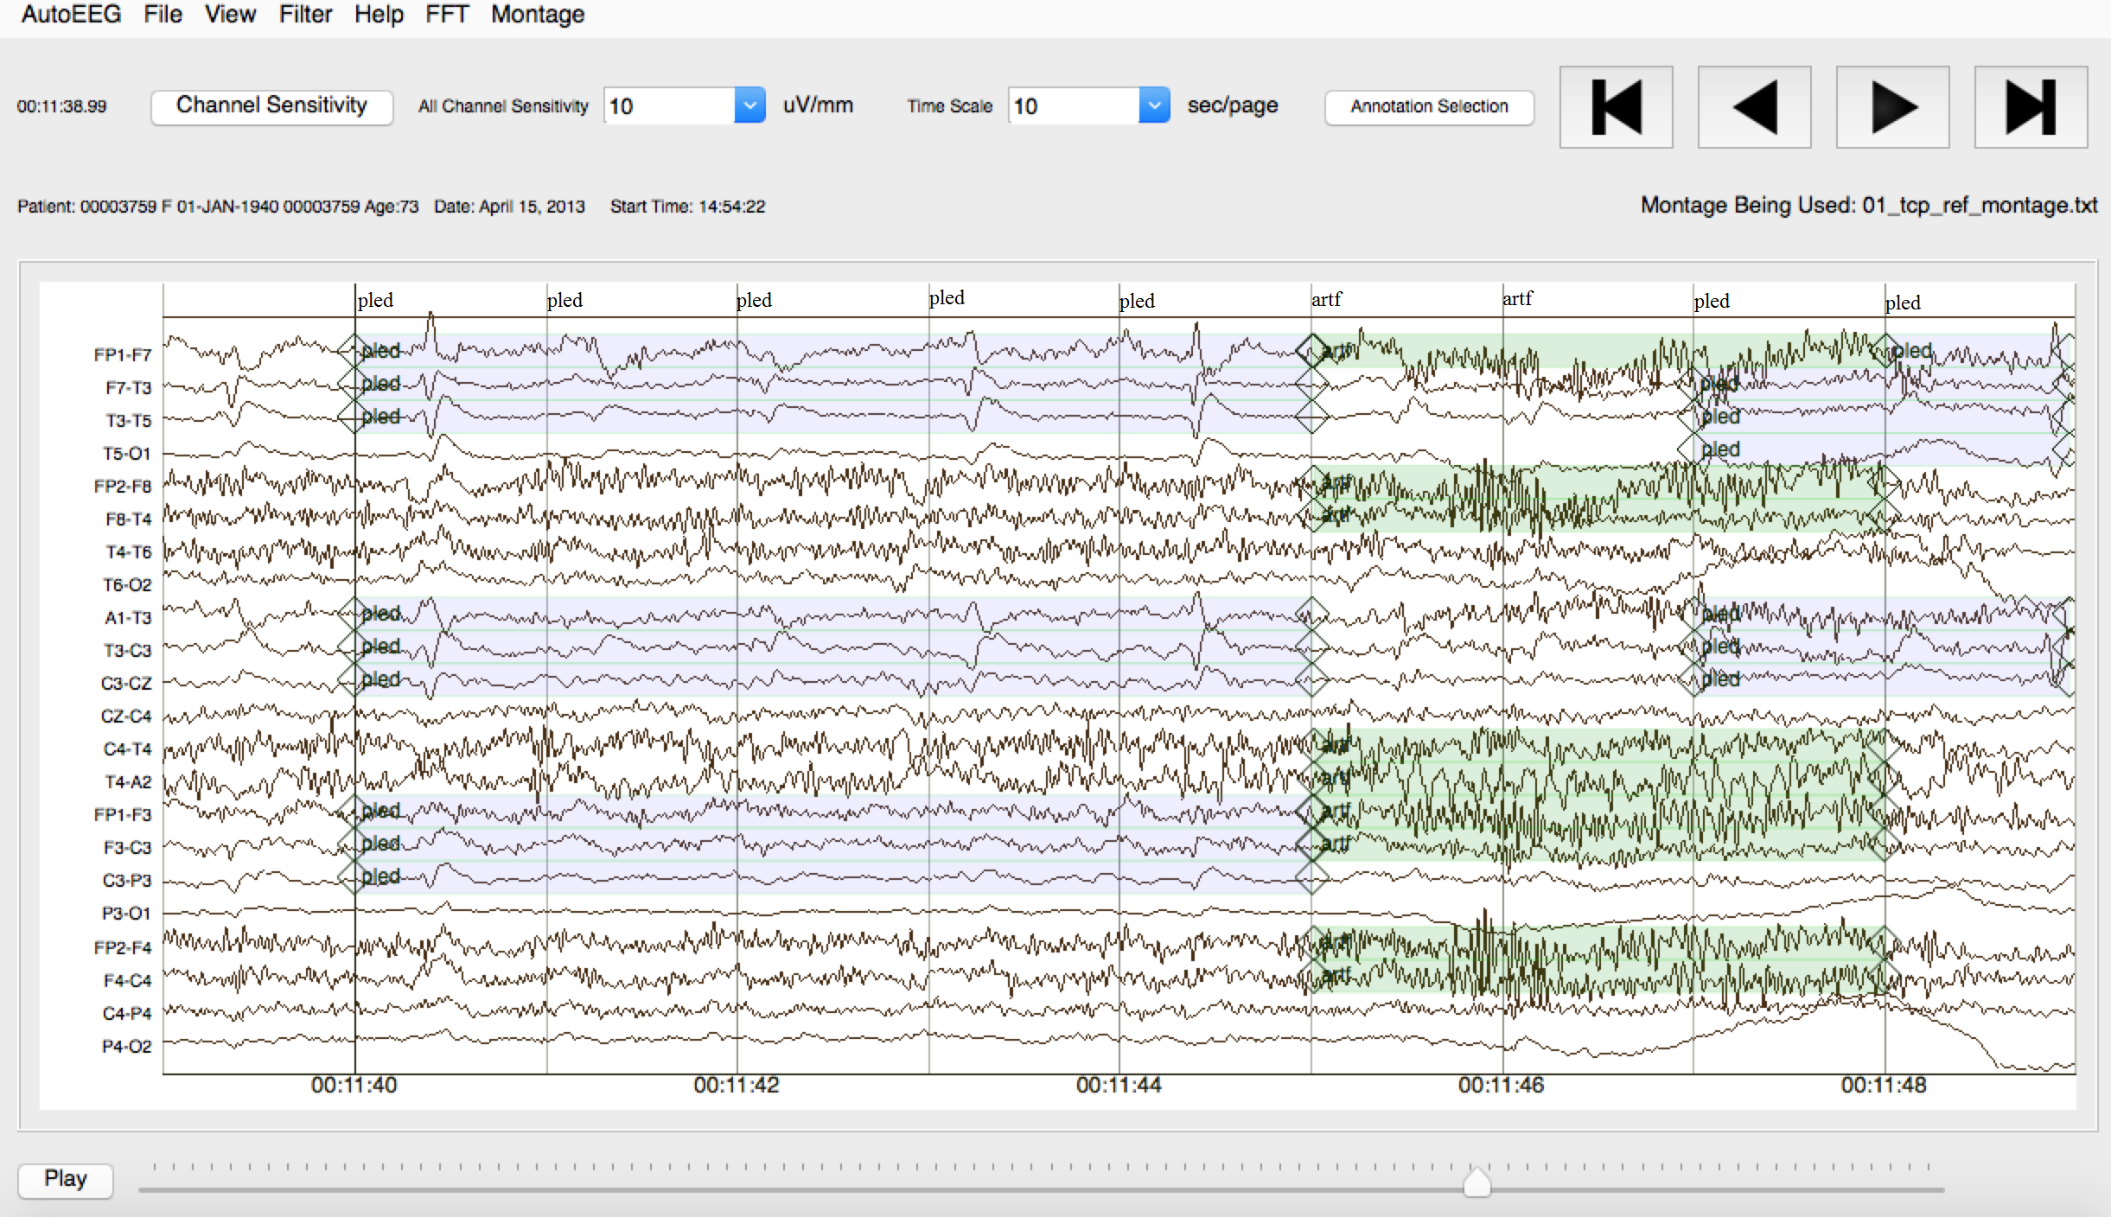

*Prepared By:*

Domenic Ochal, Safwanur Rahman, Sean Ferrell, Tarek Elseify, Iyad Obeid and Joseph Picone

The Neural Engineering Data Consortium

College of Engineering, Temple University

1947 North 12th Street

Philadelphia, Pennsylvania 19122

Tel: 215-204-4841; Fax: 215-204-5960

Email: {DomOchal, tuh01696, sean.ferrell, tug35668, iobeid, picone}@temple.edu

1. **Introduction**

The goal of this document is to describe the file formats used to store annotations for the Temple University Hospital EEG (TUEG) Corpus (Obeid & Picone, 2016). Subsets of the corpus have been manually annotated (Veloso et al., 2017) and are available from our project web site (Choi et al., 2017). These annotations are stored in two formats: a label file (*.lbl*) that represents an annotation as a hierarchical graph, and a time-synchronous event file (*.tse*) that represents an annotation as a flat series of events with start and stop times, type of seizure, and probability. In this document, we describe each of these formats. Tools to read and display this information are also available from our project web site (Capp et al., 2018; McHugh & Picone, 2016).

In this report, we discuss one particular subset of TUEG that has been extensively annotated: The TUH EEG Seizure Corpus (TUSZ). This corpus was created to support the development of automatic seizure detection technology (Golmohammadi et al., 2019) and contains four different types of annotations. An example of the annotations available for this corpus are shown in Figure 1.

total 68

drwxrwsr-x 2 tug90975 isip 4096 Aug 9 03:44 ./

drwxrwsr-x 3 tug90975 isip 4096 Aug 9 03:44 ../

lrwxrwxrwx 1 tug90975 isip 91 Aug 9 03:44 00010861_s001.txt

lrwxrwxrwx 1 tug90975 isip 96 Aug 9 03:44 00010861_s001_t000.edf

-rw-rw-r-- 1 tug90975 isip 29297 Aug 9 03:44 00010861_s001_t000.lbl

-rw-rw-r-- 1 tug90975 isip 29295 Aug 9 03:44 00010861_s001_t000.lbl_bi

-rw-rw-r-- 1 tug90975 isip 233 Aug 9 03:44 00010861_s001_t000.tse

-rw-rw-r-- 1 tug90975 isip 233 Aug 9 03:44 00010861_s001_t000.tse_bi

Figure 1. A typical directory is shown for the TUSZ Corpus. A *.txt file contains an EEG report. A *.edf file contains the EDF signal data. There are four types of annotation files included. These are described in this report.

There are six types of files available in this corpus:

*.edf: the EEG sampled data in European Data Format (edf)

*.txt: the EEG report corresponding to the patient and session

*.tse: term-based annotations using all available seizure types (multi-class)

*.tse_bi: same as *.tse except only two types of labels are used (bi-class: seizure/background)

*.lbl: event-based annotations using all available seizure types (multi-class)

*.lbl_bi: same as *.lbl except only two types of labels are used (bi-class: seizure/background)

These annotations use one of two formats: (1) *event-based:* annotations of start time, stop time, and seizure type on a specific channel; (2) *term-based:* all channels share the same annotation, which is an aggregation of the per-channel annotations. There are also two classes of annotations that are useful for machine learning research: (1) *multi-class:* annotations that provide users with the specific type of seizure event; (2) *bi-class:* simply describe whether or not a seizure has occurred. The purpose of this document is to describe these annotation standards and document the file formats used to store this information.

1. **Annotation Labels**

We currently annotate EEG data using twenty-seven labels and these are briefly described in Table 1. This table is distributed as part of the documentation directory, _DOCS, that is released with the data. This list of labels is used in all of our manual annotations involving EEG data. Each of the subsets we have developed use a specific set of labels from the twenty-seven available. We maintain this global set of symbols and do not override them or create overlapping conventions. We typically add new symbols to this list, but do not change existing symbols without a community-wide discussion (and re-mapping of existing data if required).

The TUH EEG Events Corpus (TUEV) introduces a six-way classification system and uses six of the twenty-seven labels. These were the original labels described in our initial work on automatic interpretation of EEGs (Harati et al., 2013). The annotations we developed describe six patterns of clinical interest. The first three patterns are useful in diagnosing brain disorders are:

Table 1. The labels used to annotate our EEG data are shown.

|  |  |  |
| --- | --- | --- |
| **Index** | **Label** | **Description** |
| 0 | null | An undefined annotation. Should not be seen in the data. |
| 1 | spsw | Spike and/or slow wave. A short duration epileptiform event involving an electrographic spike in activity and/or a slow wave (low frequency wave). Usually no more than 1 sec. in duration. |
| 2 | gped | Generalized periodic epileptiform discharge. Periodic diffuse spike/sharp wave discharges across multiple regions or hemispheres. |
| 3 | pled | Periodic lateral epileptiform discharge. A regular, periodically occurring spike/sharp wave seen in a certain locality of the scalp. |
| 4 | eybl | Eyeblink. A specific, sharp, high amplitude eye movement artifact corresponding to blinks. |
| 5 | artf | Artifact. Any non-brain activity electrical signal, such as those due to equipment or environmental factors. |
| 6 | bckg | All other non-seizure cerebral signals. |
| 7 | seiz | Seizure. A basic annotation for seizures. |
| 8 | fnsz | Focal nonspecific seizure. A large category of seizures occurring in a specific focality. |
| 9 | gnsz | Generalized seizure. A large category of seizures occurring in most if not all of the brain. |
| 10 | spsz | Simple partial seizure. Brief seizures that start in one location of the brain (and may spread) where the patient is fully aware and able to interact. |
| 11 | cpsz | Complex partial seizure. Same as simple partial seizure but with impaired awareness. |
| 12 | absz | Absence seizure. Brief, sudden seizure involving lapse in attention. Usually lasts no more than 5 seconds and commonly seen in children. |
| 13 | tnsz | Tonic seizure. A seizure involving the stiffening of the muscles. Usually associated with and annotated as tonic-clonic seizures, but not always (rarely there is no clonic phase). |
| 14 | cnsz | Clonic seizure. A seizure involving sustained, rhythmic jerking. Not seen in our datasets, as it is always associated with tonic clonic seizures and is annotated as such. |
| 15 | tcsz | Tonic-clonic seizure. A seizure involving loss of consciousness and violent muscle contractions. |
| 16 | atsz | Atonic seizure. A seizure involving the loss of tone of muscles in the body. Also never seen as it is always associated with an occasionally occurring phase before a tonic clonic seizure. |
| 17 | mysz | Myoclonic seizure. A seizure associated with brief involuntary twitching or myoclonus. |
| 18 | nesz | Non-epileptic seizure. Any non-epileptic seizure observed. Contains no electrographic signs. |
| 19 | intr | Interesting patterns. Any unusual or interesting patterns observed that don't fit into the above classes. |
| 20 | slow | Slowing. A brief decrease in frequency. |
| 21 | eyem | Eye movement. A very common frontal/prefrontal artifact seen when the eyes move. |
| 22 | chew | Chewing. A specific artifact involving multiple channels that corresponds with patient chewing, “bursty” |
| 23 | shiv | Shivers. A specific, sustained sharp artifact that corresponds with patient shivering. |
| 24 | musc | Muscle artifact. A very common, high frequency, sharp artifact that corresponds with agitation/nervousness in a patient. |
| 25 | elpp | Electrode pop. A short artifact characterized by channels using the same electrode “spiking” with perfect symmetry. |
| 26 | elst | Electrostatic artifact. Artifact caused by movement or interference on the electrodes, variety of morphologies. |
| 27 | calb | Artifact caused by calibration of the electrodes. Appears as a flattening of the signal in the beginning of files. |
| 28 | hphs | A brief period of high amplitude slow waves. |
| 29 | trip | Large, three-phase waves frequently caused by an underlying metabolic condition. |

1. *spike and/or sharp waves (SPSW):* patterns of EEGs observed during epileptic seizures.
2. *periodic lateralized epileptiform discharges (PLED)*: patterns observed in the context of destructive structural lesions of the cortex. PLED events manifest themselves by the presence of a pattern of repetitive periodic, focal, or hemispheric epileptiform discharges like sharp waves, spikes, spike and waves and polyspikes, at intervals ranging from 0.5 secs to 3 secs in duration.
3. *generalized periodic epileptiform discharges (GPED)*: manifest themselves as periodic short-interval diffuse discharges, periodic long-interval diffuse discharges and suppression-burst patterns. GPEDs are encountered in metabolic encephalopathy, cerebral hypoxia and ischemia. They are similar to PLEDs. In fact, if periodic complexes are limited to a focal brain area they are called as PLEDs, but if periodic complexes are observed over both hemispheres in a symmetric, diffuse and synchronized manner, they are defined as GPEDs.

The second three patterns, which are used by our machine learning technology to model non-seizure signals such as background noise, artifacts, muscle movements, head movements and chewing are:

1. *eye movement (EYEM)*: spike-like signals that occur during patient eye movement.
2. *artifacts (ARTF)*: recorded electrical activity that is not of cerebral origin including physiologic artifacts generated from sources other than the brain. This class also includes extraphysiologic artifacts arising from outside the body such as noise generated from the recording equipment.
3. *background (BCKG)*: a class used to denote all other data that does not fall in the five classes above. This class usually plays an instrumental role in machine learning systems and needs to include a rich variety of artifacts that are not events of clinical interest.

The annotation files available within TUSZ contain thirteen different labels that consist of seizure events and background annotations. In multi-class annotations, there are eleven specific seizure labels used: (1) focal non-specific seizure (FNSZ), (2) generalized seizure (GNSZ), (3) simple partial seizure (SPSZ), (4) complex partial seizure (CPSZ), (5) absence seizure (ABSZ), (6) tonic seizure (TNSZ), (7) clonic seizure (CNSZ), (8) tonic-clonic seizure (TCSZ), (9) atonic seizure (ATSZ), (10) myoclonic seizure (MYSZ), and (11) non-epileptic seizure (NESZ). In bi-class annotations the specific seizure is not annotated, only whether a seizure has occurred. This is labeled as seizure (SEIZ). The only non-seizure annotation within TUSZ, background (BCKG), is used to identify background.

Six labels are used to define specific artifact annotations in an EEG signal file: (1) eye movement (EYEM), (2) chewing (CHEW), (3) shivering (SHIV), (4) muscle artifact (MUSC), (5) electrode pop (ELPP), and (6) electrostatic artifact (ELST). The TUH EEG Slowing corpus contains slowing (SLOW) annotations that signify a brief decrease in frequency (von Weltin et al., 2017). Any unusual or interesting patterns observed in an EEG file that don’t fit with the previously mentioned annotations are defined as interesting (INTR) annotations. An undefined annotation that should not be seen in EEG data is denoted as null (NULL). We use NULL to facilitate and simplify software development.

Next, we discuss how these labels are stored in the two annotation file formats we support. This is important to understand because users will typically write scripts to extract this information and format it to meet the requirements of their specific machine learning environment.

1. **File FORMATS**

We decided not to use an XML format because in our experience this is a bit of a challenge for our typical users, who are often entry-level students, to comprehend. XML parsing is not difficult in Python, but many of the researchers we support do not have this type of programming support within their small research groups. Similarly, in our research group it is uncommon that our undergraduate programmers have experience with XML parsing. Hence, we decided to keep the formats very simple ASCII text-based formats. (However, we expect to transition to XML soon as part of our work in image classification.)

We support two types of file formats: *.tse and *.lbl. In this section we describe these formats. These can be easily parsed using a scripting language such as Python.

* 1. **The Time-Synchronous Event (*.TSE) FILE Format**

Time-synchronous event files use term-based annotations and incorporate all available seizure type classes in TUSZ. This type of annotation file uses one label that applies to all channels for each event. These are extremely useful for machine learning research because the overall classification of a segment is the only concern, not the individual channels. The format of a typical time-synchronous event file is shown in Figure 2.

The specific version of the tse file is defined on the first line of each file. The current version is v1.0.0 and stored as a text string in a name/value pair in the first line of the file. The values on each line following the version declaration use a simple format that consist of four fields: (1) the start time in seconds, (2) the stop time in seconds, (3) the annotation label, and (4) probability of the label. The last field is set to 1.0 by default for manually annotated files. For machine generated files, such as a recognition hypothesis, it is set to a posterior probability, confidence value, or the equivalent.

nedc_000 [1]: cat 00000492_s003_t004.tse

version = tse_v1.0.0

0.0000 10.2775 bckg 1.0000

10.2775 35.7775 gnsz 1.0000

35.7775 102.2525 bckg 1.0000

102.2525 142.9800 gnsz 1.0000

142.9800 339.0000 bckg 1.0000

Figure 2. A typical “*.tse” file in TUSZ is shown. All segments of the signal are accounted for this in example.

For the example provided in Figure 2, line three corresponds to a background (BCKG) annotation from 0.0000 seconds to 10.2775 seconds with a probability of the defined label being 1.0000. The following line describes a generalized seizure (GNSZ) from 10.2775 seconds to 35.7775 seconds, and the probability of that annotation being 1.0000. The remaining lines follow the same format.

We typically use four decimal places for these numbers so that precision extends slightly beyond the number of decimal places required to uniquely describe each signal sample. EEG files are often sampled at a frequency that ranges between 250 Hz, which corresponds to a sample period or duration of 4 ms (0.004 secs), and 1000 Hz, which corresponds to a sample duration of 1 ms (0.001 secs). Therefore, a sample of the signal is uniquely identifiable by four decimal places of precision. There is no requirement that the precision be limited to four decimal places, though extending this precision slightly increases the amount of disk space required to store these files.

A time-synchronous event file need not account for the entire signal duration. There can be gaps or only portions of the signal can be annotated. However, we typically annotate the entire signal duration using our annotation tools (Capp et al., 2017).

* 1. **The Label (*.LBL) File Format**

Label files use event-based annotations that are more complicated compared to time-synchronous event files and essentially describe a graph that can represent a hierarchical annotation (e.g., FNSZ and GNSZ map to SEIZ). These files describe the specific channel or set of channels on which an event occurred. Channel labels are provided within the file in order to represent the exact channel for which the event occurred on. An example label file within TUSZ is provided in Figure 3.

The structure of an *.lbl file is as follows:

* *Version Number:* similar to a *.tse file, a *.lbl file begins with the version number on the first line stored as a name/value pair.
* *Montage Block:* The section of text following the version declaration is the montage definition for that specific patient session. This is described in more detail in Ferrell et al. (2019). The format for this section is a name/value pair that lists each component of the montage using the channel index, the label, and the labels for the original channels used to form this output channel.
* *Level Block:* The next two fields following the montage definition section describe the number of levels and sublevels. Levels are used to create a hierarchical structure. Sublevels are used to track data, i.e. iterations or sources. For TUAZ, we use one level and one sublevel for seizure annotations. This level describes the label used for each annotation (Figure 3).
* *Symbol Block:* This block defines the symbols used for annotation. It is a mapping of text labels to indices that are used in the following block. These labels are listed as a dictionary mapping the annotation indices to annotation abbreviations (i.e., 0 is mapped to NULL, 1 is mapped to SPSW, etc.).

s003_2003_07_18 : cat /01_tcp_ar/004/00000492/s003_2003_07_18/00000492_s003_t004.lbl

version = lbl_v1.0.0

montage = 0, FP1-F7: EEG FP1-REF -- EEG F7-REF

montage = 1, F7-T3: EEG F7-REF -- EEG T3-REF

...

montage = 20, C4-P4: EEG C4-REF -- EEG P4-REF

montage = 21, P4-O2: EEG P4-REF -- EEG O2-REF

number_of_levels = 1

level[0] = 1

symbols[0] = {0: '(null)', 1: 'spsw', 2: 'gped', 3: 'pled', 4: 'eyem', 5: 'artf', 6: 'bckg', 7: 'seiz', 8: 'fnsz', 9: 'gnsz', 10: 'spsz', 11: 'cpsz', 12: 'absz', 13: 'tnsz', 14: 'cnsz', 15: 'tcsz', 16: 'atsz', 17: 'mysz', 18: 'nesz', 19: 'intr', 20: 'slow', 21: 'eyem', 22: 'chew', 23: 'shiv', 24: 'musc', 25: 'elpp', 26: 'elst'}

label = {0, 0, 0.0000, 10.2775, 0, [0.0, 0.0, 0.0, 0.0, 0.0, 0.0, 1.0, 0.0, 0.0, 0.0, 0.0, 0.0, 0.0, 0.0, 0.0, 0.0, 0.0, 0.0, 0.0, 0.0, 0.0, 0.0, 0.0, 0.0, 0.0, 0.0, 0.0]}

label = {0, 0, 10.2775, 35.7775, 0, [0.0, 0.0, 0.0, 0.0, 0.0, 0.0, 0.0, 0.0, 0.0, 1.0, 0.0, 0.0, 0.0, 0.0, 0.0, 0.0, 0.0, 0.0, 0.0, 0.0, 0.0, 0.0, 0.0, 0.0, 0.0, 0.0, 0.0]}

label = {0, 0, 35.7775, 102.3525, 0, [0.0, 0.0, 0.0, 0.0, 0.0, 0.0, 1.0, 0.0, 0.0, 0.0, 0.0, 0.0, 0.0, 0.0, 0.0, 0.0, 0.0, 0.0, 0.0, 0.0, 0.0, 0.0, 0.0, 0.0, 0.0, 0.0, 0.0]}

...

label = {0, 0, 35.7775, 102.3525, 21, [0.0, 0.0, 0.0, 0.0, 0.0, 0.0, 1.0, 0.0, 0.0, 0.0, 0.0, 0.0, 0.0, 0.0, 0.0, 0.0, 0.0, 0.0, 0.0, 0.0, 0.0, 0.0, 0.0, 0.0, 0.0, 0.0, 0.0]}

label = {0, 0, 102.3525, 142.9800, 21, [0.0, 0.0, 0.0, 0.0, 0.0, 0.0, 0.0, 0.0, 0.0, 1.0, 0.0, 0.0, 0.0, 0.0, 0.0, 0.0, 0.0, 0.0, 0.0, 0.0, 0.0, 0.0, 0.0, 0.0, 0.0, 0.0, 0.0]}

label = {0, 0, 142.9800, 339.0000, 21, [0.0, 0.0, 0.0, 0.0, 0.0, 0.0, 1.0, 0.0, 0.0, 0.0, 0.0, 0.0, 0.0, 0.0, 0.0, 0.0, 0.0, 0.0, 0.0, 0.0, 0.0, 0.0, 0.0, 0.0, 0.0, 0.0, 0.0]}

Figure 3. A typical “*.lbl” file is shown for an example signal selected from the TUSZ Corpus. This is a flat or single‑level annotation.

* *Label Block*: The last section within a label file portrays the channel indexes in numerical order following the format: level, sublevel, start time in seconds, stop time in seconds, channel, and a vector of probabilities for each label. These are normally set to 0 or 1 for manually generated annotations, but for machine learning outputs a full range of values can be present, and more than one element can be non-zero.

The first annotation labeled in Figure 3 is background on channel 0. This event extends over the range [0.0000, 10.2775]. Because the 7th value in the label field vector is equal to 1.0, and the 7th label in the symbol vector is “6: bckg”, this label denotes an event labeled “bckg” or background. The next annotation for channel 0 covers the range [10.2775, 35.775] and indicates a seizure has occurred. The 10th index in the label field is 1.0, which corresponds to a label of “spsz”. This indicates a simple partial seizure has occurred.

The labels continue for channel 0, and then for channel 1, 2, ..., 21. Note that the last label shown in Figure 3 accounts for the interval [142.9800, 339.000] on channel 21, which indicates this file is 339.0000 secs long. This interval is marked as “bckg” because the 7th index has a non-zero probability.

In Figure 4 we provide an example of a multi-level annotation. In Figure 5, we show a visualization of this annotation. Annotations are time-aligned with the signal at all levels of the hierarchical description. The annotation begins with *level[0]*. At this level, a seizure event is typically identified as “seizure” or “background” ­– a high-level description of the event. In this case, the event is background.

version = lbl_v1.0.0

# define the channel assignments:

montage = 0, FP1-F7: EEG FP1-REF -- EEG F7-REF

montage = 1, F7-T3: EEG F7-REF -- EEG T3-REF

…

# define the number of levels

number_of_levels = 2

# define the number of sub-levels:

level[0] = 2

level[1] = 3

# define the labels available at each level:

symbols[0] = {0: ‘seiz’,1: ‘bckg’}

symbols[1] = {0: '(null)', 1: 'spsw', 2: 'gped', 3: 'pled', 4: 'eyem', 5: 'artf', 6: 'bckg', 7: 'seiz', 8: 'fnsz'}

# level:0 sublevel:0 (level 0 annotators)

#

label = {0, 0, 0.0000, 6.0000, 0, [0.0, 1.0]};

label = {0, 0, 0.0000, 6.0000, 1, [0.0, 1.0]};

# level:0 sublevel:1 (level 0 system 1)

#

label = {0, 1, 0.0000, 6.0000, 0, [0.2350, 0.7650]}

label = {0, 1, 0.0000, 6.0000, 1, [0.2970, 0.7030]}

# level:1 sublevel:0 (level 1 annotators)

#

label = {1, 0, 4.0000, 6.0000, 0, [0.0, 0.0, 0.0, 0.0, 1.0, 0.0, 0.0, 0.0, 0.0]};

label = {1, 0, 4.0000, 6.0000, 1, [0.0, 0.0, 0.0, 0.0, 1.0, 0.0, 0.0, 0.0, 0.0]};

label = {1, 0, 4.0000, 6.0000, 2, [0.0, 0.0, 0.0, 0.0, 1.0, 0.0, 0.0, 0.0, 0.0]};

# level:1 sublevel:1 (level 1 system 1)

#

label = {1, 1, 4.0000, 5.0000, 0, [0.0000, 0.0000, 0.3000, 0.0000, 0.5000, 0.2000, 0.0000, 0.0000, 0.0000]};

label = {1, 1, 5.0000, 6.0000, 1, [0.0000, 0.0000, 0.0500, 0.0000, 0.1500, 0.8000, 0.0000, 0.0000, 0.0000]};

label = {1, 1, 4.0000, 6.0000, 2, [0.0000, 0.0000, 0.1750, 0.0000, 0.7250, 0.1000, 0.0000, 0.0000, 0.0000]};

# level:1 sublevel:2 (level 1 system 2)

#

label = {1, 2, 5.0000, 6.0000, 0, [0.00, 450.92, 0.00, 0.00, 5032.29, 0.00, 0.00, 0.00, 0.00]};

label = {1, 2, 4.0000, 6.0000, 1, [0.00, 460.72, 0.00, 0.00, 4892.10, 0.00, 0.00, 0.00, 0.00]};

label = {1, 2, 4.0000, 6.0000, 2, [0.00, 504.92, 0.00, 0.00, 5920.12, 0.00, 0.00, 0.00, 0.00]};

Figure 4. A multi-level annotation described in an “*.lbl” file. This file describes an annotation that has three levels for a background event so that they type of background event can be accurately described.

In the second level, *level[1]*, the specific type of this background event is identified. In this case, part of the background event is labeled as EYEM (eye movement), as shown in Figure 5. There is no limit to the number of levels or the degree of specification that can be achieved with them.

In this example, each level has two sublevels. These sublevels have many uses, but here they are used to differentiate the types of annotations. At *level[0]*, the first sublevel, *sublevel 0* shows annotations made by NEDC annotators, while *sublevel 1* shows annotations made by an automated system, system 1. Sublevel three, which only occurs on the second level, *level[1]*, contains the annotations made by a second system, system 2. The use of multiple sublevels allows for easy classification and structuring.

Sublevels are a general way to add more detail to the annotation of an event and integrate alternate descriptions of the same event. As seen above, a sublevel can be used to show the probabilities in different formats or differentiate between annotations created by separate systems. In the TUEG and TUSZ, only a single sublevel is used, *sublevel 0*. This sublevel denotes annotations as created by the annotators at NEDC.

In the visualization in Figure 5, we see that level[0] records the event as background. Background is then further differentiated as described above. Note that it is not necessary to classify all of *level[0]* down to *level[2]*. A background annotation may stop at any level. In this way, the “lbl” format allows an annotation to be represented as an unbalanced tree.

BCKG (Level 0)

EYEM (Level 1)

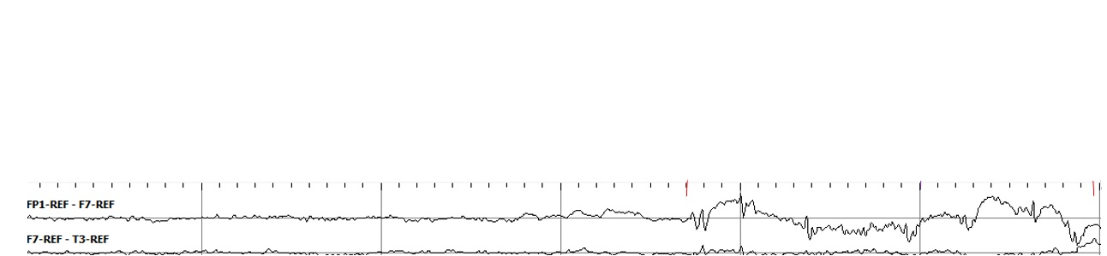

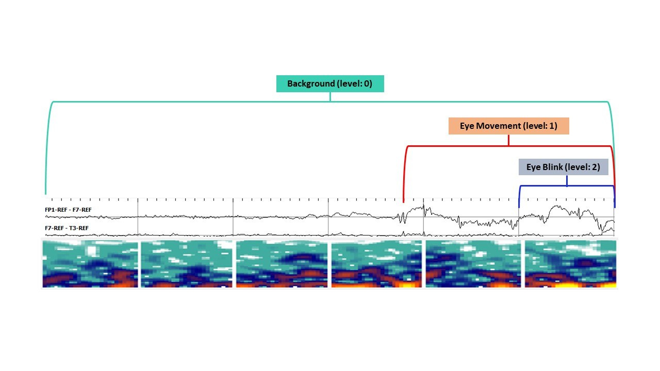

Figure 5. A visualization of the heirarchal annotation described in Figure 4

1. **Annotation CoNventions**

Our approach to annotation of EEG signals has evolved since our initial work in 2012. We have worked closely with a team of neurologists at Temple Hospital to understand their workflow and their clinical needs. We have refined our annotation process to better characterize their clinical needs and the needs of our machine learning technology. These standards were developed to consistently distinguish seizure, slowing, and artifact events with a high degree of accuracy and precision.

The conventions listed here identify key characteristics used in identification of seizure, slowing, and artifact events. Seizure, slowing, and artifact events are then further differentiated into their respective subtype of event (i.e. absence seizure vs. simple partial seizure). Examples of signals that are similar in appearance to the events of interest are given to show the recognizable features that distinguish each event from its common sources of errors.

NEDC annotation standards continue to undergo revisions and refinements to improve the quality of data. The conventions and standards listed here are those we have used through December 2019. We will be releasing an updated version of this document in 2020 that reflects two significant changes. First, we are converting our annotation file formats to use XML. Second, we are reviewing previous annotations of all the data to make sure they are accurate and consistent. This will result in a release titled v1.5.1 (dev and eval data has been reviewed) and v1.5.2 (training data has been reviewed).

* 1. **THE PROCESS OF ANNOTATION**

The development of a team of undergraduates that can accurately annotate seizures has been an interesting journey (Shah et al., 2020). Annotation is carried out by a team dedicated solely to EEG interpretation. These annotators are Temple University students who have undergone several months of rigorous training in order reach annotation skills on par with our standards. They must be able to recognize and classify seizure and artifact events with a high degree of interrater reliability so as to maintain the integrity of the TUEG. These students usually have a STEM background, and often are pursuing degrees in neuroscience or bioengineering.

During the first round of annotation, a single annotator will check each file for seizure events. If an annotator is unable to make a definitive judgment on an event, the annotator will mark this file for a review from a more senior member of the group. If the senior member is unable to discern whether the event is in fact seizure or not, that senior member will mark this file to be reviewed during a weekly meeting. At this meeting, events are annotated on a consensus basis.

Following the completion of the first round of annotation for every file in the set, a round of reviews will begin. For a new data set, each file will be reviewed by two annotators individually. This redundancy is in place to reduce the number of missed events, so that all precious seizure data is harvested, and all annotations are accurate, orderly, and meet our standards.

For a data set that has already undergone the first set of annotation and review, sometimes a revision is in order. Revisions may be carried out on the entirety of the set, as is sometimes the case for an old set which needs to be brought up to current standards, or for a subset of the data set. This may be a review of seizure files only, which acts to ensure the highest accuracy of our seizure data and screen out any false alarms, or a review of files marked as seizure by the machine learning system, to find missed seizures and reduce the rate of false negatives. These reviews are done to ensure the best possible accuracy for the data. The corpus has undergone numerous revisions by the annotation team, each time refining the data and implementing more precise and exact standards to enhance the clarity and accuracy of the data.

Revision is done by either a two or three annotator per file system. The first annotator reviews the previous annotations for accuracy. If this annotator decides no change is necessary, the file is then marked as such. Another annotator will check this file. If the second annotator agrees, the file is then marked as complete with no necessary changes. If the second annotator does not agree, it will be checked by a third annotator as a tiebreaker. If the first annotator decides a change is necessary, they will make the appropriate changes. These changes will be reviewed by the second and third annotators. If they are affirmed, the changes will be kept. If not, the three annotators will review the file and come to a consensus.

Annotations are created by viewing files using our annotation tool (Capp et al., 2018) or EDF Browser (Beelen, 2013), an open-source EEG software, and the annotating files in the demo tool. Both are multiplatform tools that support the Windows and Mac operating systems. EDFBrowser runs better under Windows and is useful for quickly annotating long segments of data. Our annotation tool provides both time domain and frequency domain visualizations, making it ideal for accurate detection of seizure onsets.

We begin the discussion of our specific conventions by describing a normal EEG. We then discuss sleep states and both seizure and non-seizure events that we annotate.

* 1. **THE NORMAL EEG**

A normal EEG of an awake adult consists of constant, low amplitude activity in either the alpha or beta ranges. The EEG will show the normal artifacts associated with an awake patient such as eye blinks/movements and muscle artifact. A major component of the normal EEG is the Posterior Dominant Rhythm. The Posterior Dominant Rhythm is sometimes called the alpha rhythm, because its fundamental frequency is typically in the range of 8‑12 Hz. The Posterior Dominant Rhythm occurs primarily over the occipital electrodes spreading with a gradual decrease in reflection towards the frontal polar electrodes. The Posterior Dominant Rhythm occurs in awake patients and is normally attenuated by eye opening. An example is shown in Figure *6*.

An additional finding is present in children and young adults called alpha waves of youth. This activity is an exaggerated version of the Posterior Dominant Rhythm found in older patients. It occurs in the same frequency range but shows an even greater amplitude and more generous field of spread. An example is shown in Figure 7.

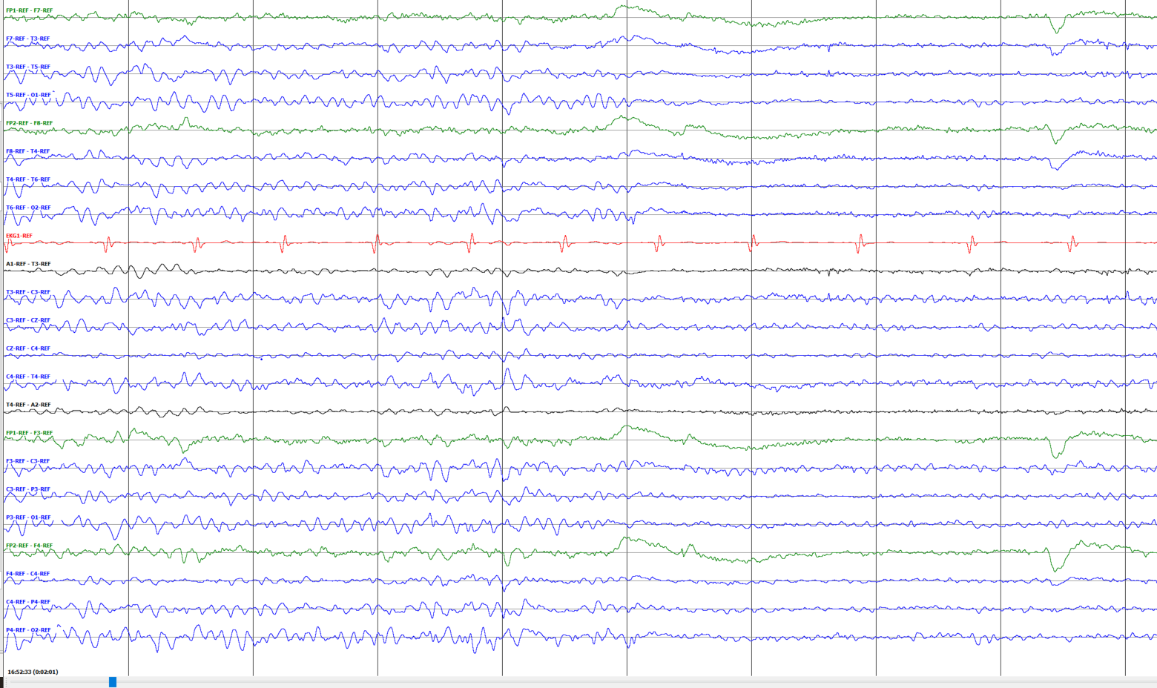

Figure 6. A normal EEG is shown that contains a Posterior Dominant Rhythm which attenuates with eye closing (single arrows).



Figure 7. A normal EEG with alpha waves of youth

* 1. **NORMAL SLEEP**

Sleeping patients show several other normal signals in their EEG records. These signals may be discreet events such as K-complexes and sleep spindles, shown in Figure 8, or the presence of slow waves as the record slips into lower frequency ranges during drowsiness and sleep, as shown in Figure 9:

*K-complexes:* These are individual complexes that occur during the second stage of sleep in normal patients. These events occur approximately every 1 to 2 minutes and are usually followed by sleep spindles. K-complexes consist of a high amplitude (>100 µV), diphasic discharge and occur simultaneously across all or most channels. An example is shown in Figure 8.



Figure 8. A K-complex and an associated sleep spindle during normal sleep

*Sleep Spindles:* These are 0.5-2 second events that consist of 11‑16 Hz smooth waves of moderate amplitude. Unlike K-complexes, these events generally occur on only one or a few channels at once. An example is shown in Figure 8.



*Vertex Wave:* These are individual complexes with the appearance of a transient sharp wave, as shown in Figure 9. They occur with an amplitude between 50-150 µV during non-REM 1 and non-REM 2 sleep. Vertex waves are similar in appearance to K-complexes but are more spatially confined and narrower. In children and young adults, it’s possible for vertex waves to occur in a repetitive run, giving the appearance of ictal activity. However, they are completely normal occurrences.

* 1. **Seizure EVENTS**

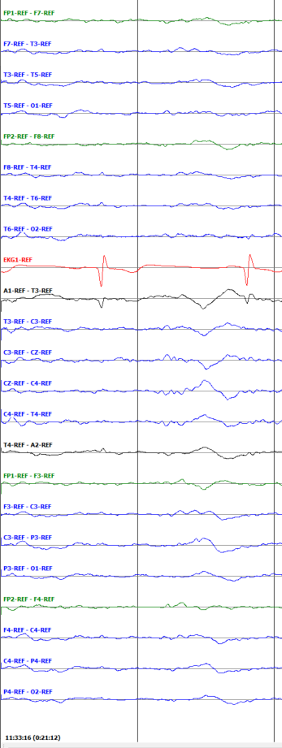

Figure 9. A typical vertex wave

TUEG contains a wide variety of events that are relevant to the seizure detection problem. We have chosen to create tags for their annotation based on their utility for machine learning research. The events we tag can be either seizure, ictal non-seizure, cerebral non-ictal, or artifact. To delineate a seizure event from background, annotators look for several distinct characteristics: evolution, a spike or polyspike and slow wave morphology, rhythmicity, synchrony, continuity, and frequency. Seizures must be at least 10 seconds long and contain no gaps longer than 3 seconds. If there is a gap of greater than 3 seconds, the events are considered two distinct seizures and are annotated as such. One seizure may contain multiple annotations on an individual channel, as long as there is persistent activity on a single channel.

*Focal Non-Specific Seizure (Tag: FNSZ):* Focal non-specific seizures cover a broad range of seizure etiologies. As such, they have significant variation in appearance, length, and focality. In a focal nonspecific seizure, the primary indicator of a seizure event is the morphology. The seizure will show a spike and slow wave (Figure 10) or a polyspike and slow wave complex (Figure 11). Spikes are brief changes in amplitude that occur in approximately one tenth of a second or less. Slow waves may be in the order of alpha, theta, or delta, but rarely occur at greater than 10 Hz or less than 2 Hz during a seizure. The continuity of the spike and slow wave complexes at regular intervals constitutes a seizure in TUEG. These complexes will be synchronous, occurring within a fifth of a second of each other between channels on all channels included in the seizure event.

On many occasions, the morphology is not distinct enough to conclusively indicate the presence of a seizure. Another major indicator of a seizure event is an increase in amplitude associated with a general decrease in frequency as the seizure progresses. This is shown in Figure 12 and Figure *13*. Note that evolution may occur in as little as a second or appear to progress over the course of several minutes.

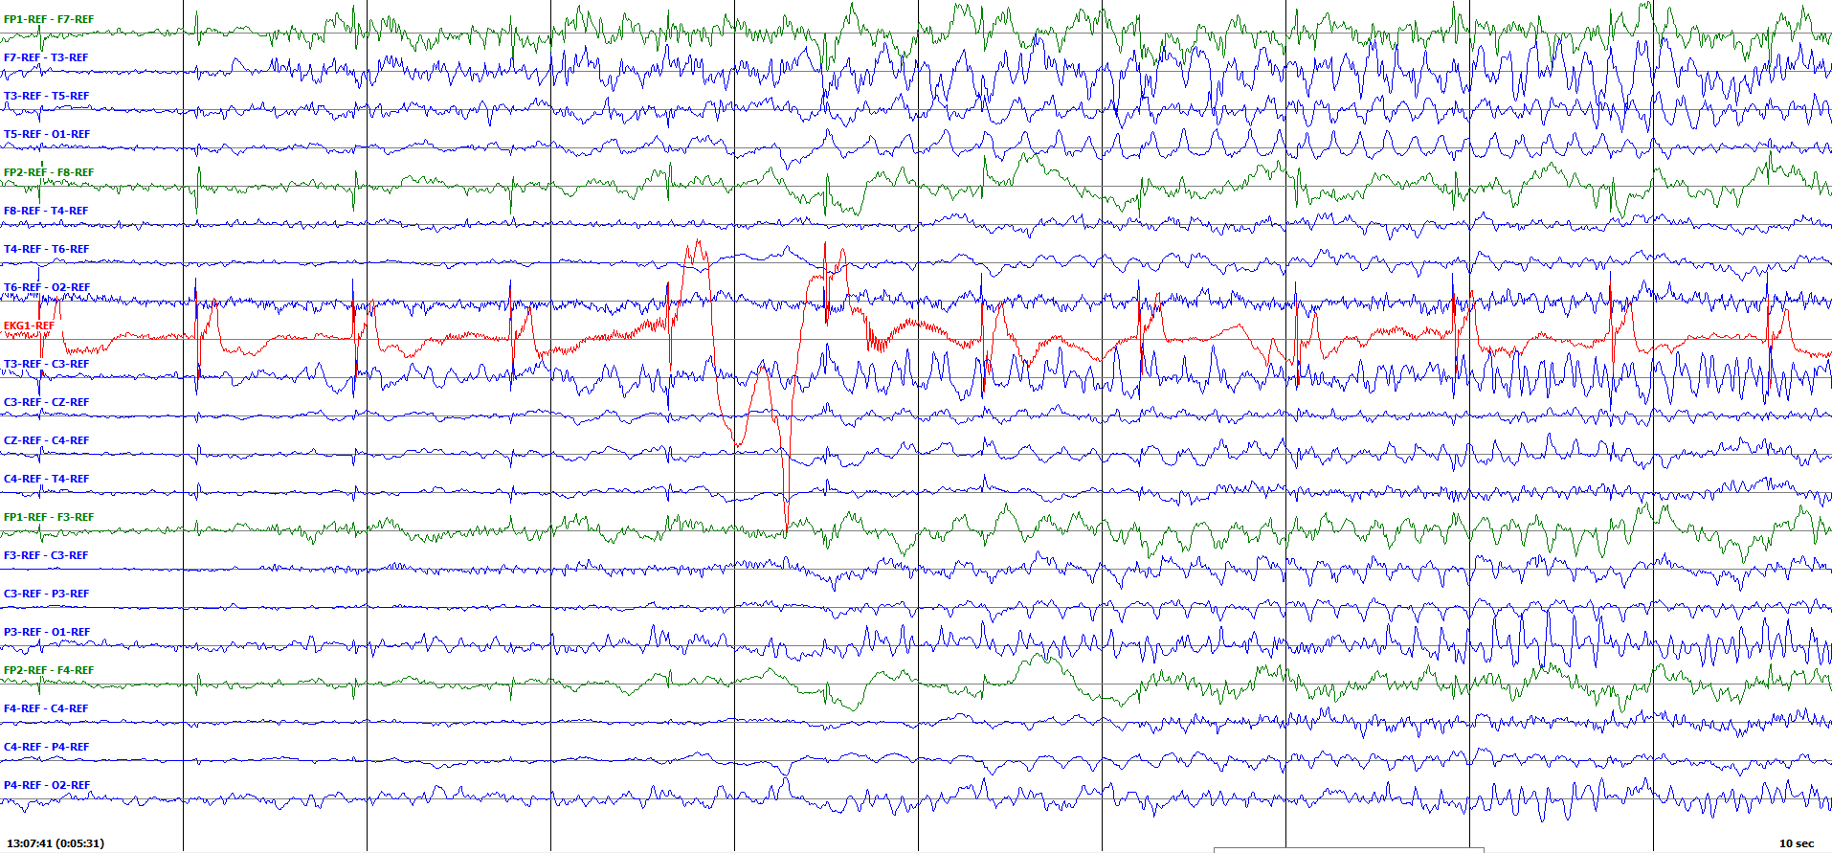

Figure 10. A spike and slow wave (~5 Hz) pattern of a focal non-specific seizure

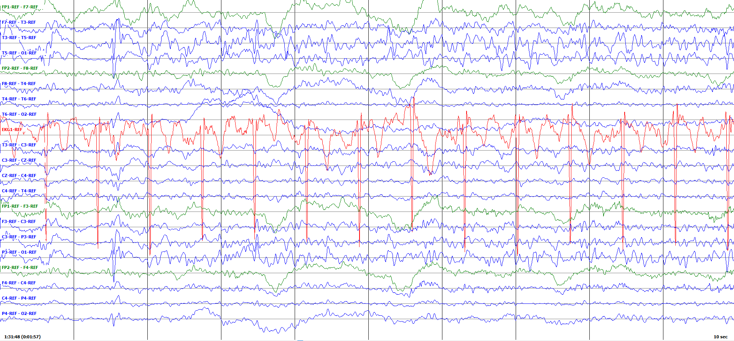

Figure 11. A polyspike and slow wave (~5 Hz) pattern during a focal non-specific seizure

Another key indicator of a seizure is postictal slowing. Postictal slowing occurs just after a seizure and is characterized by 1-3 Hz slow waves that are indicative of the confused/unconscious state patients experience following a seizure. Figure 14 shows the end of a focal non-specific seizure and the slowing which follows. Postictal slowing is not a part of the seizure and is therefore not annotated as such.

Focal non-specific seizures are delineated from general non-specific seizures only by the number and location of the channels on which they occur. Focal non-specific seizures then cover all seizures that do not encompass a majority of channels or the majority of the surface of the head. This includes single electrode seizures, frontal seizures, temporal seizures, posterior seizures, hemispheric seizures, or combinations thereof. Focal non-specific seizure may evolve into general non-specific seizures over the course of the event if the seizure spreads to more areas of the brain.

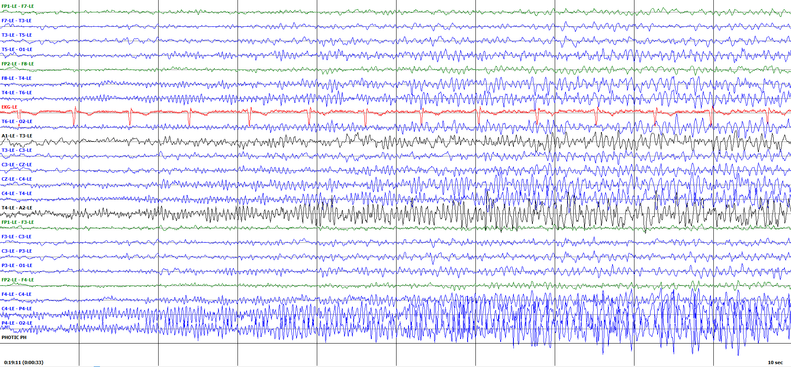

Figure 12. The evolution of a seizure marked by an increase in amplitude over time

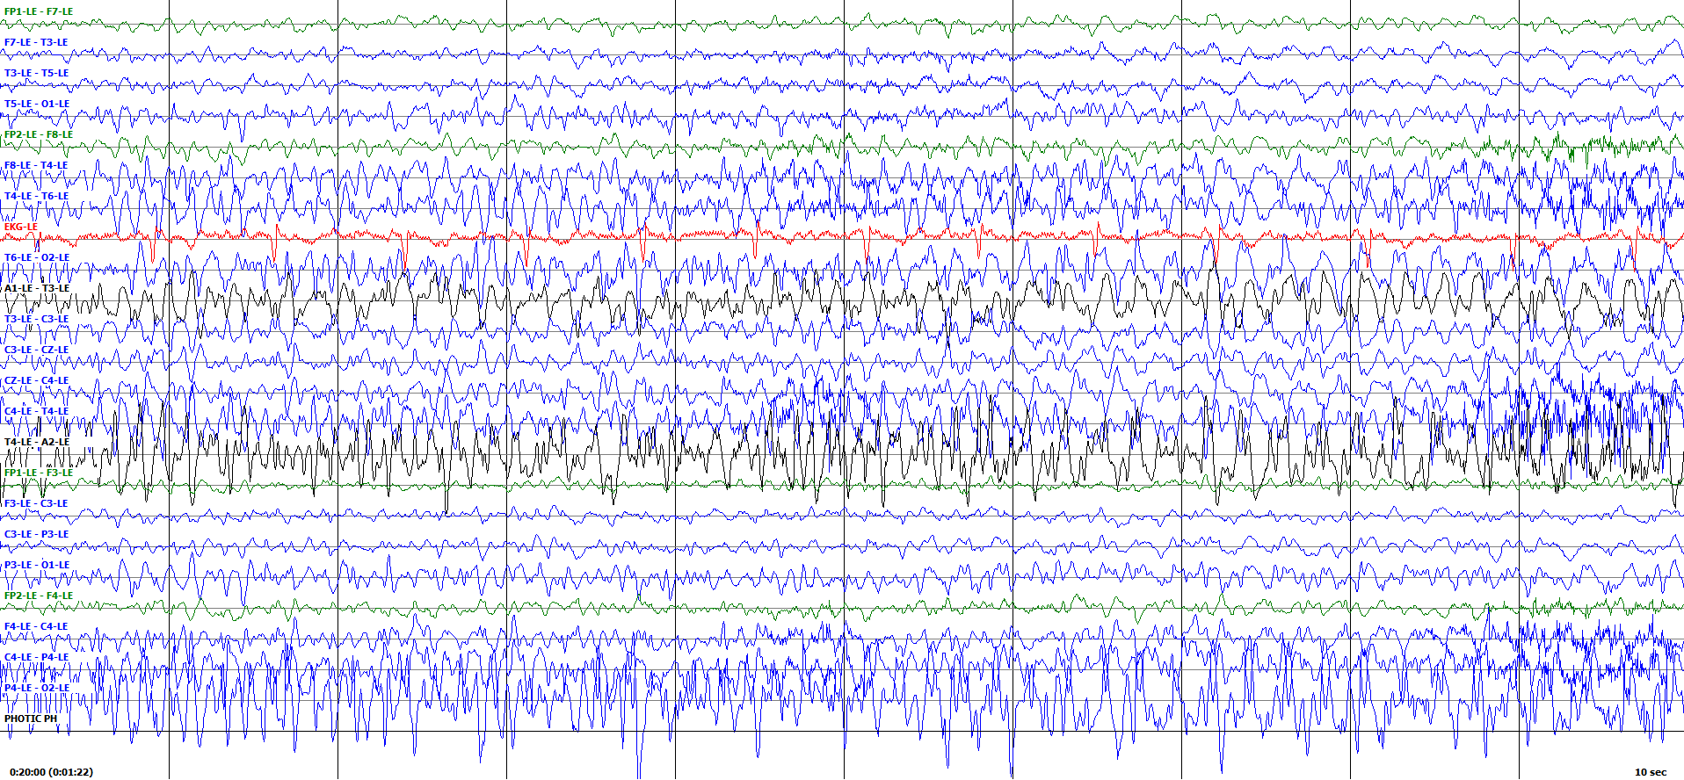

Figure 13. The evolution of a seizure marked by a decrease in the average frequency over time

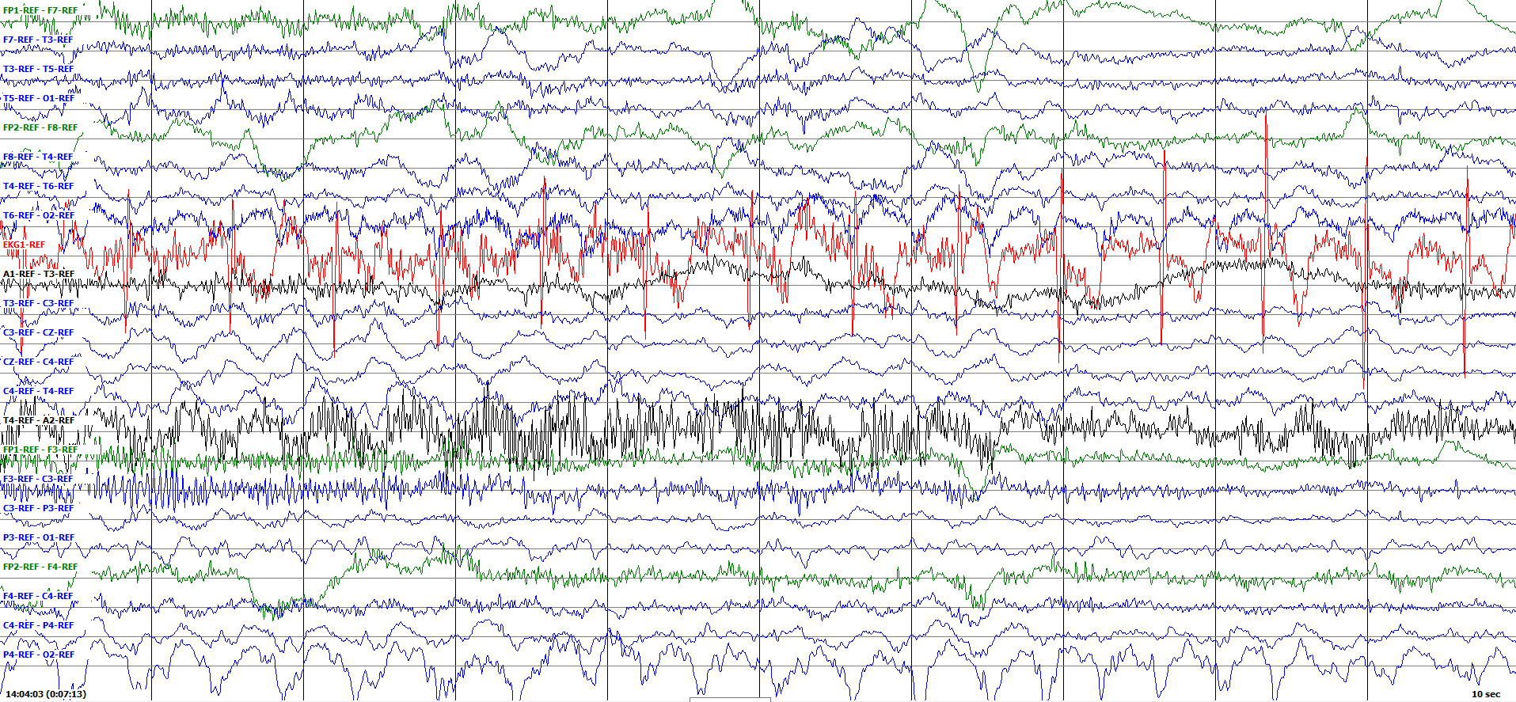

Figure 14. Slow waves seen following a focal non-specific seizure (approximate end marked with arrow)

*General Non-Specific Seizures (Tag: GNSZ)*: General non-specific seizures are very closely related to focal non-specific seizures. They follow the same morphology, evolution, postictal slowing, and frequency descriptors, but they cover a greater number of channels and area of the skull. An example is shown in Figure 15.

Synchrony is very important in a general non-specific seizure. The complexes on each channel in a general non-specific seizure are expected to have temporal overlap within a fifth of a second. This seemingly small point is highlighted on the rare occasion on which a patient has two focal non-specific seizures occurring simultaneously. The only way to effectively determine whether a seizure is generalized or is a combination of two or more seizures is to check for synchrony between the channels.

*Tonic-Clonic Seizures (Tag: TCSZ):* Tonic-Clonic seizures are a type of seizure that are characterized by muscle tension and stiffening followed by violent convulsions and jerking. As such, these seizures are characterized by a distinct flattening of the EEG followed by intense muscle artifact. An example of this transition is shown in Figure 16. The actual cerebral activity of a tonic clonic seizure is the same as that of either a focal non-specific or generalized non-specific seizure. The focality may be difficult to determine, as the cerebral activity is generally disguised by intense muscle artifact. As the seizure progresses, it may become impossible to detect the underlying cerebral activity because the muscle artifact will continue to grow in intensity until the seizure comes to an end. This is shown in Figure 17.

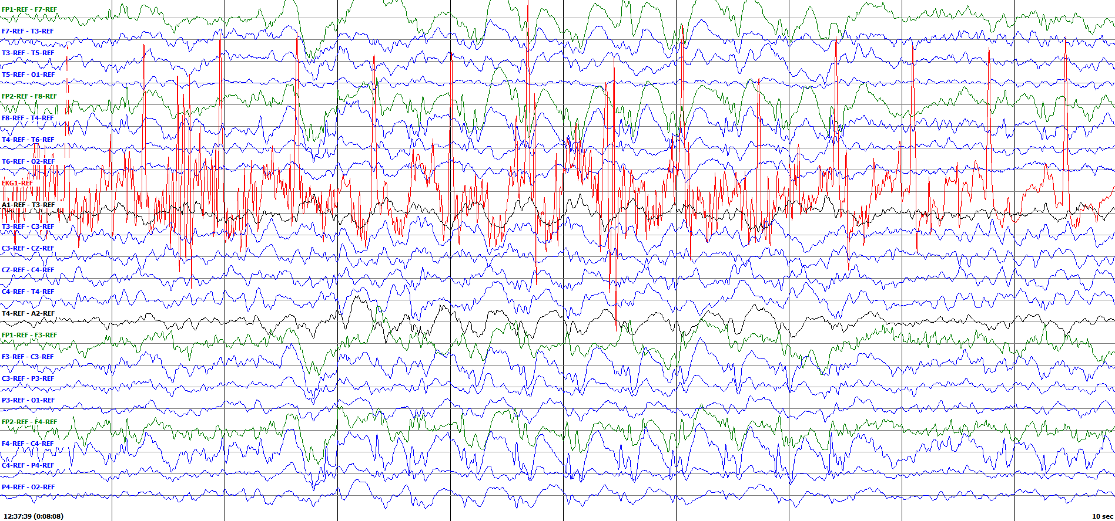

Figure 15. A generalized seizure as indicated by the presence of spikes and slow waves on both the right and left hemispheres

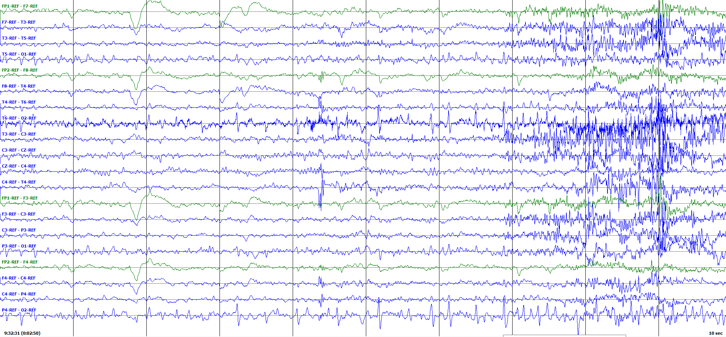

Figure 16. The flattening of the EEG known as the atonic phase seen just before the beginning a tonic-clonic seizure

*Myo-Clonic Seizures (Tag: MYSZ):* Myoclonic seizures are generally very brief ­­– a single jerk can be considered a myoclonic seizure. As such, they are rarely annotated in the EEG corpus, because it is nearly impossible to differentiate an ictal jerk from a non-ictal jerking movement. However, there are some rare instances where the myoclonus may persist for several seconds or where clinical reports indicate the presence of myoclonic seizures. The seizures will show the characteristic spike and wave complexes of a focal or general nonspecific seizure, but they will be overlaid with periodic jerks. Figure 18 shows a focal myoclonic seizure.

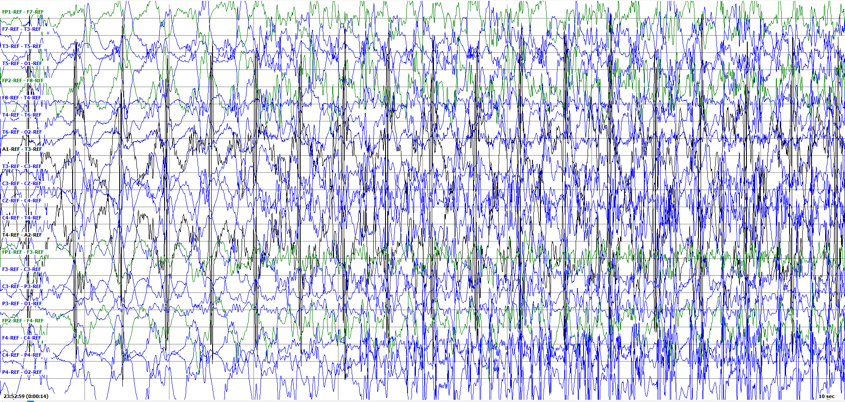

Figure 17. A tonic-clonic seizure becoming completely obscured by a muscle artifact

*Absence Seizures (Tag: ABSZ):* Absence seizures are brief seizures that should contain no muscle artifacts. They show a characteristic spike or polyspike and wave morphology that begins abruptly, lasts a brief period of time, and ends just as abruptly as it began. An example is show in Figure 19. Absence seizures are frequently high amplitude and very sharp, leaving little room for error. An exception is made for these seizures, as they are so distinct, they do not need to be 10 seconds in duration.

*Simple Partial Seizures (Tag: SPSZ):* A simple partial seizure is another name for a focal seizure, as simple partial seizures are always focal. The only way to differentiate a simple partial seizure from a focal non-specific seizure is with clinical data. This is because the “simple” indicates that the patient maintained awareness throughout the seizure – an unusual clinical finding. TUEG uses the reports to decide whether a seizure is simple partial or focal non-specific. Although this is not currently useful in automated seizure detection, assuring that no data that may be of future importance is lost in the annotation process was a major goal of our work. These seizures follow the same morphology as a focal non-specific seizure: a spike and wave complex, frequently with evolution and postictal slowing.

Complex Partial Seizures (Tag: CPSZ): A complex partial seizure is the inverse of a simple partial seizure. Complex partial seizures are focal seizures in which the patient does not maintain awareness. Again, this can only be indicated with clinical data captured in the EEG report. Complex partial seizures follow the same morphology of focal non-specific seizures characterized by spike and wave discharges, evolution, and postictal slowing.

* 1. **ARTIFACT EVENTS**

In addition to seizure events, the TUH EEG corpus contains many events classified as artifact. Artifacts are signals that are non-cerebral in origin. The most common causes of artifact are associated with the patient’s movement. Other causes include electrode glitches, sweating, or nearby sources of electromagnetic fields.

The TUH EEG corpus has a series of annotated artifacts events for the purpose of artifact reduction. The types of events annotated are some of the most common events seen in the corpus or are known to contribute the greatest source of error in a machine learning system.

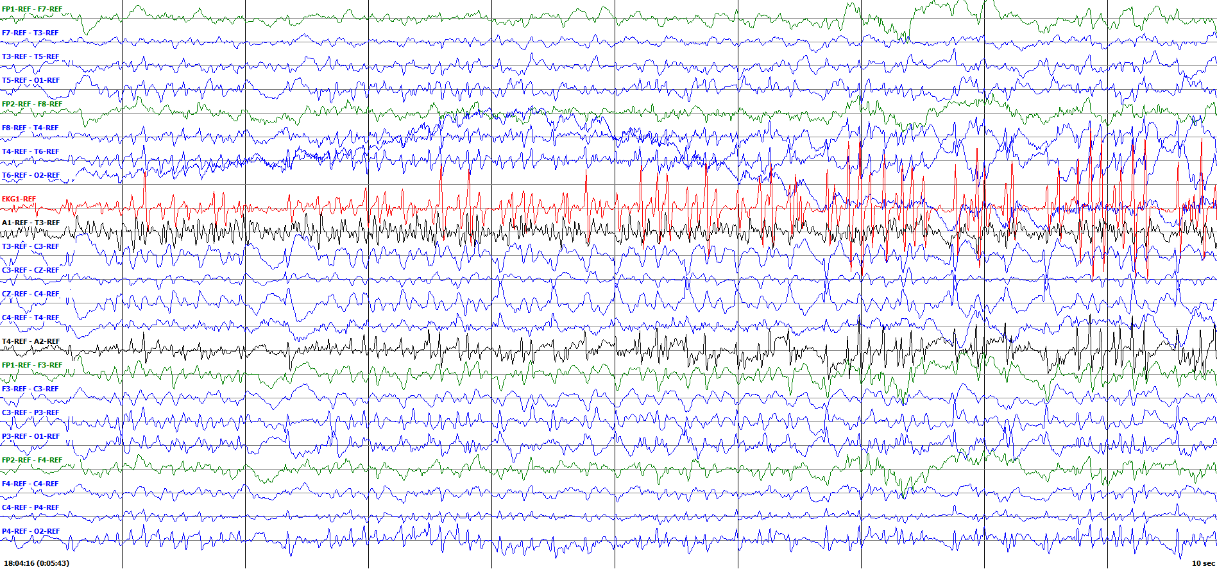

Figure 18. A myoclonic seizure is shown. The temporally locked spikes (arrows) occurring across channels are due to the rhythmic jerking motion of the patient.

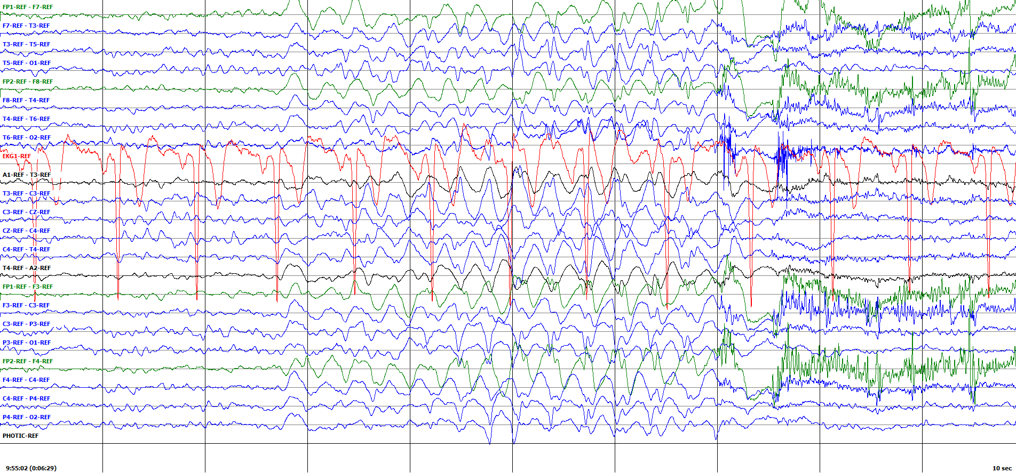

Figure 19. The rapid occurrence, high amplitude, and rapid disappearance are indicative of an absence seizure.



Figure . The rapid occurrence, high amplitude, and rapid disappearance all indicate this to be an absence seizure.

*Muscle Artifact (Tag: MUSC):* Muscle artifact is associated with any type of movement and is later subdivided into many classes of muscle artifact. The characteristic feature of this artifact is high frequency content in the signal as shown in Figure 20. Muscle artifacts typically occur at 30+ Hz with no discernable pattern. The amplitude ranges from very low to very high. This artifact is also closely associated with tonic-clonic seizures, as the patient begins convulsing during the clonic portion of the event as was seen in Figure 17.

*Shivering Artifact (Tag: SHIV):* Shivering artifact is a subset of muscle artifact that happens when the patient shivers. Shivering artifact has a characteristic complex that consists of a medium amplitude sharp that swoops into a higher amplitude spike before dipping below baseline followed by the initiation of another complex These complexes typically occur in the beta frequency and are on the majority of channels. An example is shown in Figure 21.

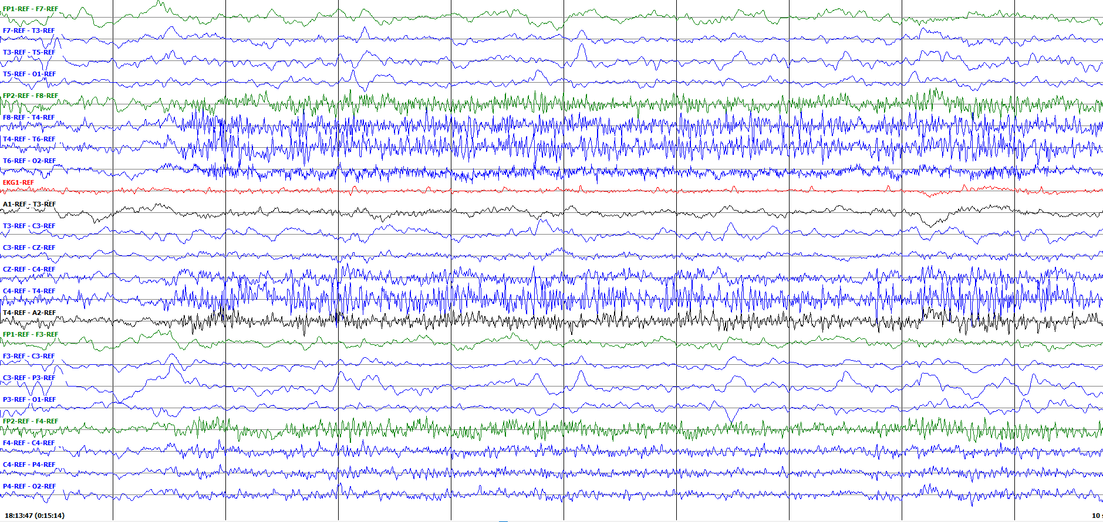

Figure 20. A portion of muscle artifact indicated by the high frequency and moderate to high amplitude morphology

Although a shivering artifact is rare, it is a significant source of error when it does occur. The shivering morphology in many cases appears analogous to a spike and slow wave seen in typical seizure morphologies, albeit at higher frequency. In these instances, the determinants for seizure are based on the event’s frequency, evolution, and the presence of postictal slowing.

*Chewing Artifact (Tag: CHEW):* A chewing artifact is a subset of muscle activity that results from tensing and relaxing the jaw. This artifact has the characteristic high frequency activity of normal muscle artifact, with ~0.5 second periods of baseline between them. An example is shown in Figure 22. Chewing occurs primarily on the temporal channels with generous spread and may show greater activity in one hemisphere.

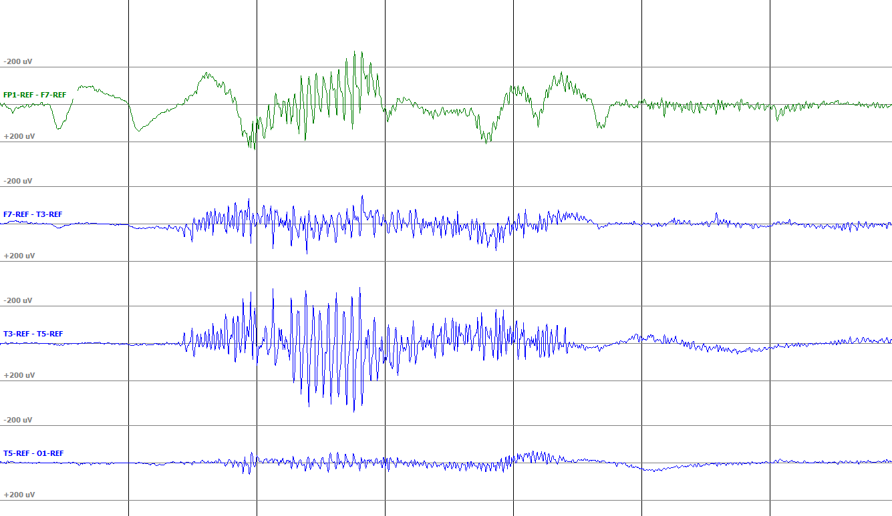

Figure 21. Notice the distinct sharp-into-spike morphology of the shivering event. This event was cropped to four channels for clarity, but it frequently occurs across all or most channels.

A chewing artifact is common in the corpus as normal patients may tense and relax their jaws during sleep. In some instances, chewing can be associated with seizure. In these cases, the brief returns to baseline that occur during chewing will often show some form of spike and slow wave activity characteristic of a seizure event. We also tend to use the EEG report in these instances to confirm that the patient shows chewing associated with a seizure.

*Eye Blink Artifact (Tag: EYBL):* An eye blink artifact is caused by the movement of frontal polar electrodes on the forehead. An example is shown in Figure 23. This event shows a single high amplitude sharp wave followed by a slow wave of opposite polarity. These events occur primarily on the frontal polar electrodes but may echo on the frontal electrodes. Large spans of frequent eye blink artifact may be associated with neurological dysfunction. Such an example is shown in Figure 24.

It is easy for annotators to differentiate eyeblink artifact from seizure events by looking for consistency and the spike and slow wave of seizure events. Moreover, seizure events that occur during spans of rapid eye blinking will be readily recognized by their regularity, spatial confinement, and spike and slow wave morphology.

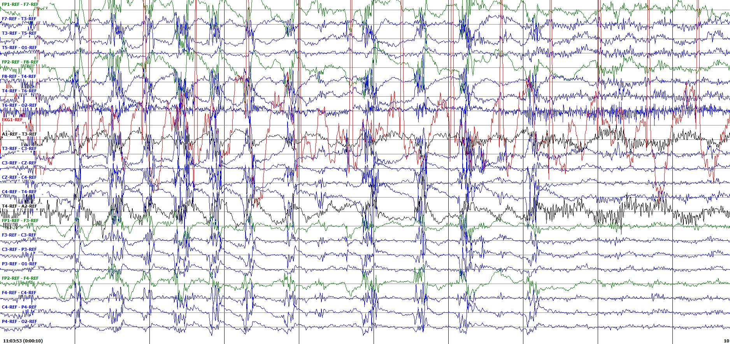

Figure 22. A chewing artifact

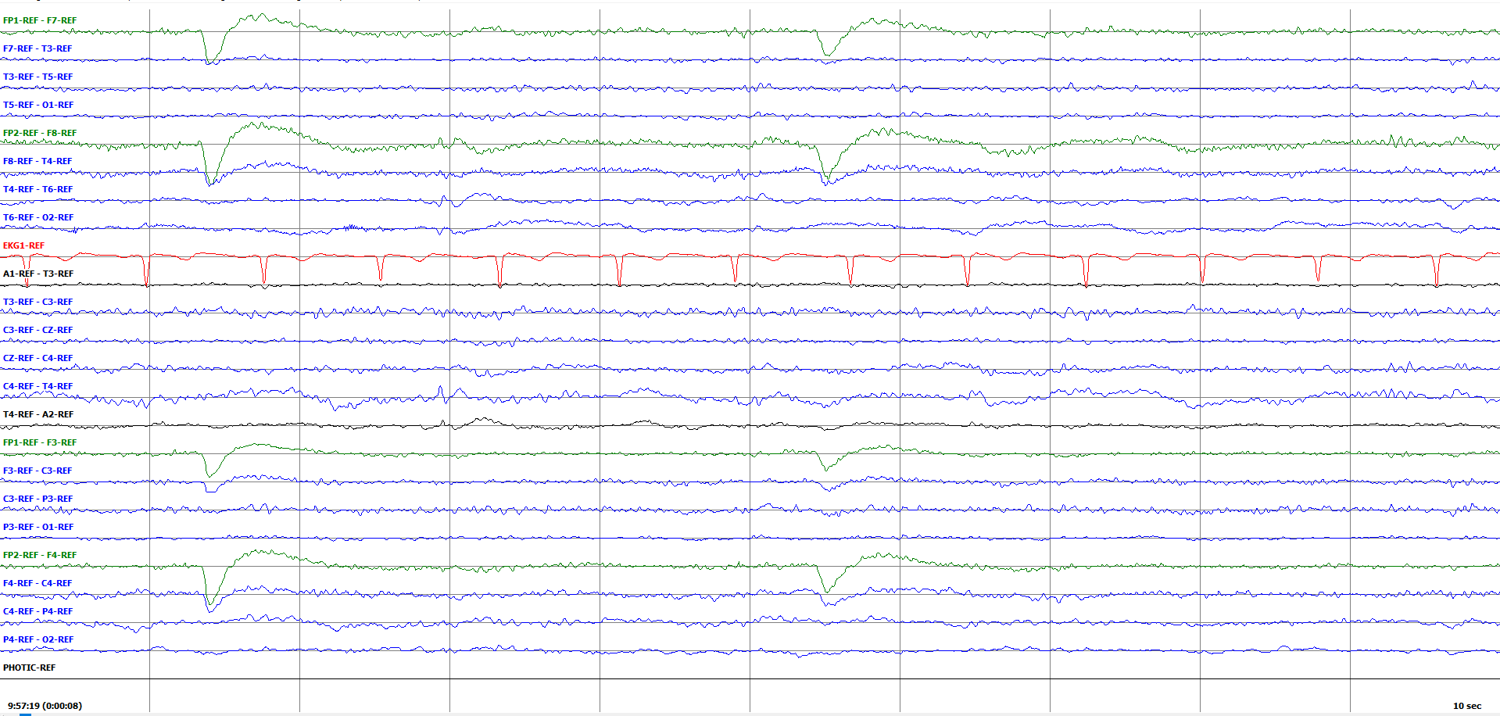

Figure 23. A single eye blink

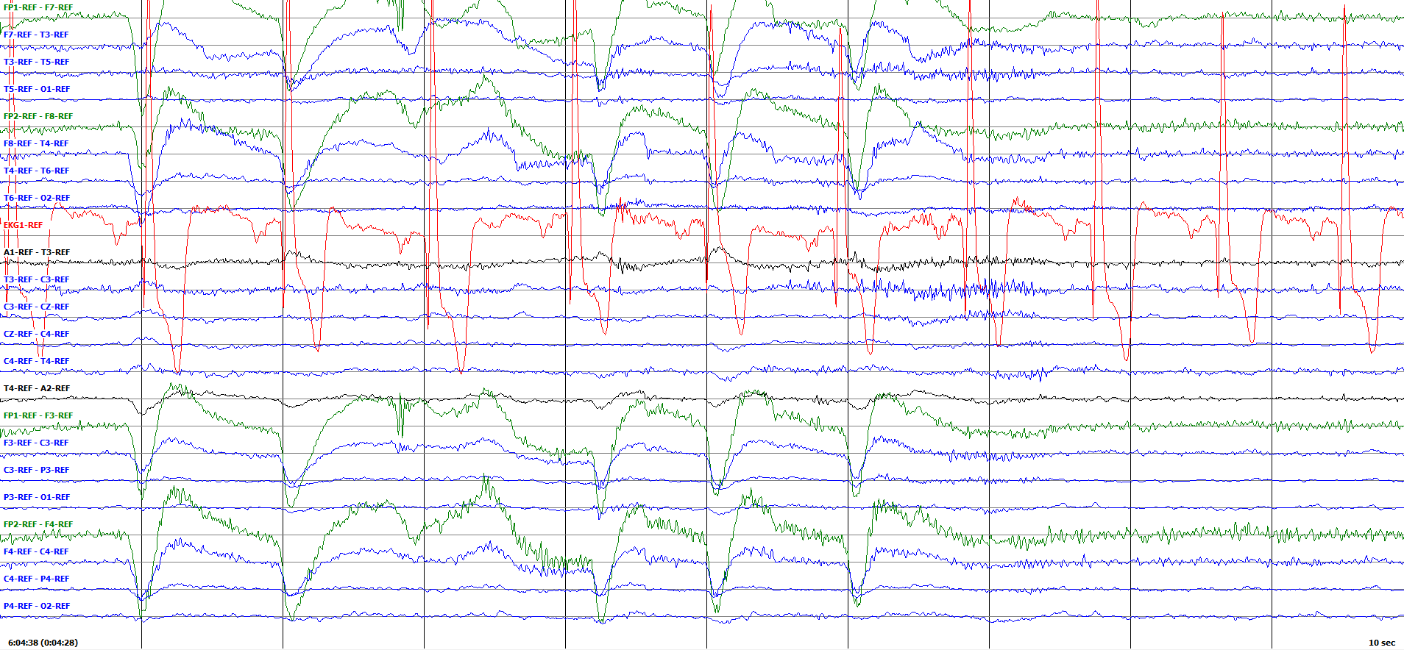

Figure 24. A series of eye blinks which may be associated with a degree of neurological dysfunction

*Eye Movement Artifact (Tag: EYEM):* This artifact is caused by movement of the patient’s eyes. These movements create a wave on the frontal polar electrodes as shown in Figure 25. In neurological dysfunction, it is common for these events to occur in rapid succession. An example is shown in Figure 26. The result is a series of waves which occur largely on the frontal polar electrodes, with some echoing on the frontal electrodes.

Large spans of eye movement artifact contribute to error in automated seizure detection, as the recurrent waves may mimic seizure morphology. Key descriptors that allow annotators to differentiate between eye movement artifacts and seizure are the characteristic spike or polyspike which occurs in seizure as well as the irregularity or discontinuity of eye movement events.

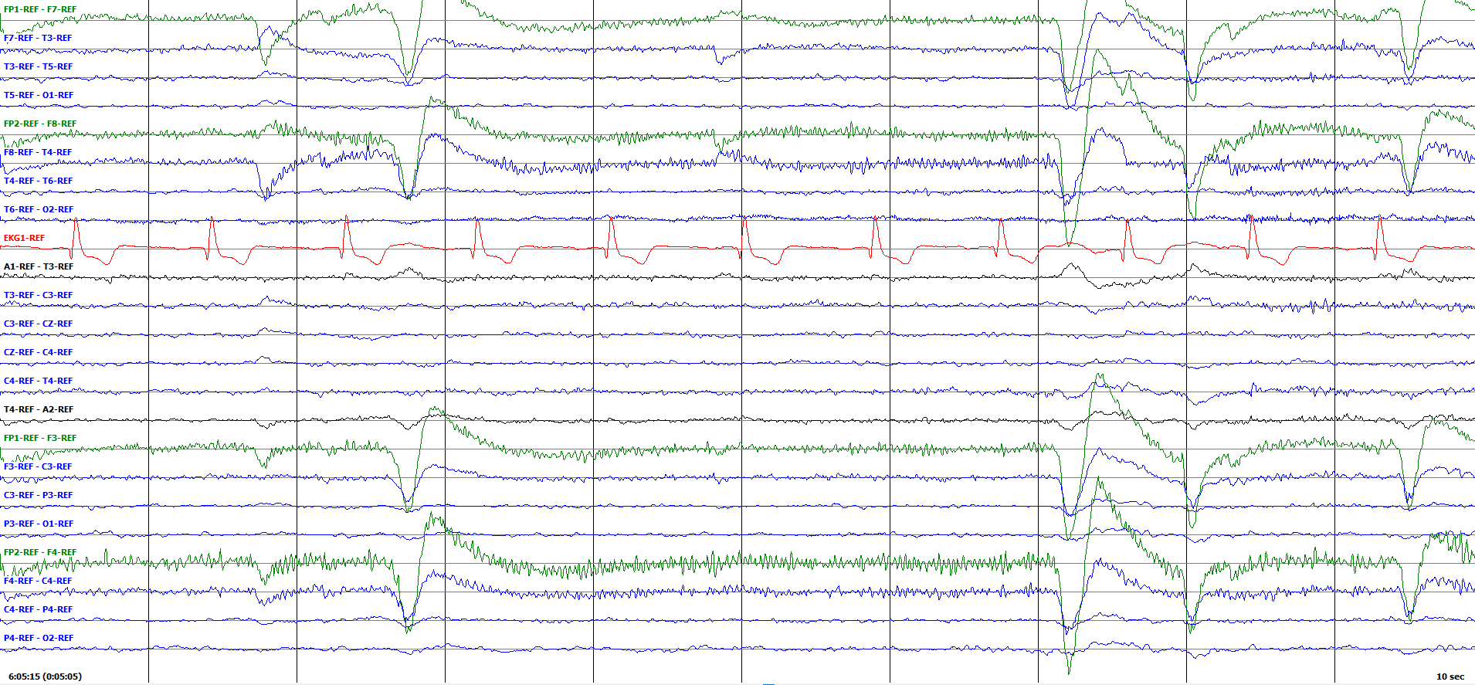

Figure 25. A single lateral eye movement



Figure 26. A series of eye movements.

In the event that continuous eye movement occurs at the same time as a seizure event, the underlying seizure is frequently obvious. The seizure event will typically occur on channels where eye movement does not occur and will be more regular than the eye movement. The two events will also be out of phase and the seizure should show characteristic spike and slow wave morphology.

*Electrode Pop Artifact (Tag: ELPP):* An electrode pop artifact results from a glitch at an individual electrode and may be the result of improper adhesion or bubbles in the gel used to fix the electrodes to the scalp. This glitch causes a rapid (on the order of single milliseconds) change in amplitude on a single electrode, as shown in Figure 27. This change is very sharp and easily distinguishable from events that are cerebral in origin. In some instances, an electrode will pop repeatedly and continue to pop throughout the record, as shown in Figure 28. This is not unusual and may make it difficult or impossible to extract seizure data from that electrode.

*Electrostatic Artifact (Tag: ELST):* An artifact labeled ELST is the result of a small electrostatic discharge from the patient. The common occurrence, which most people have experienced, sends a very brief, high amplitude spike through the EEG. An example of this is shown in Figure 29, which was adapted from Britton et al. (2016). This spike may appear similar to a jerk artifact, but it is unipolar and consists of only one sharp spike, where a jerk artifact has two. The ELST tag does not currently appear in our corpus (as of v1.5.1).

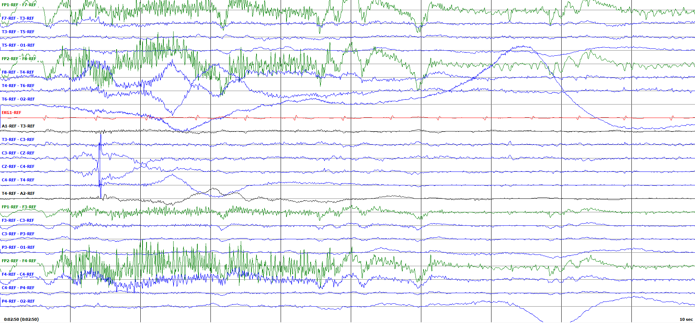

Figure 27. A single electrode pop

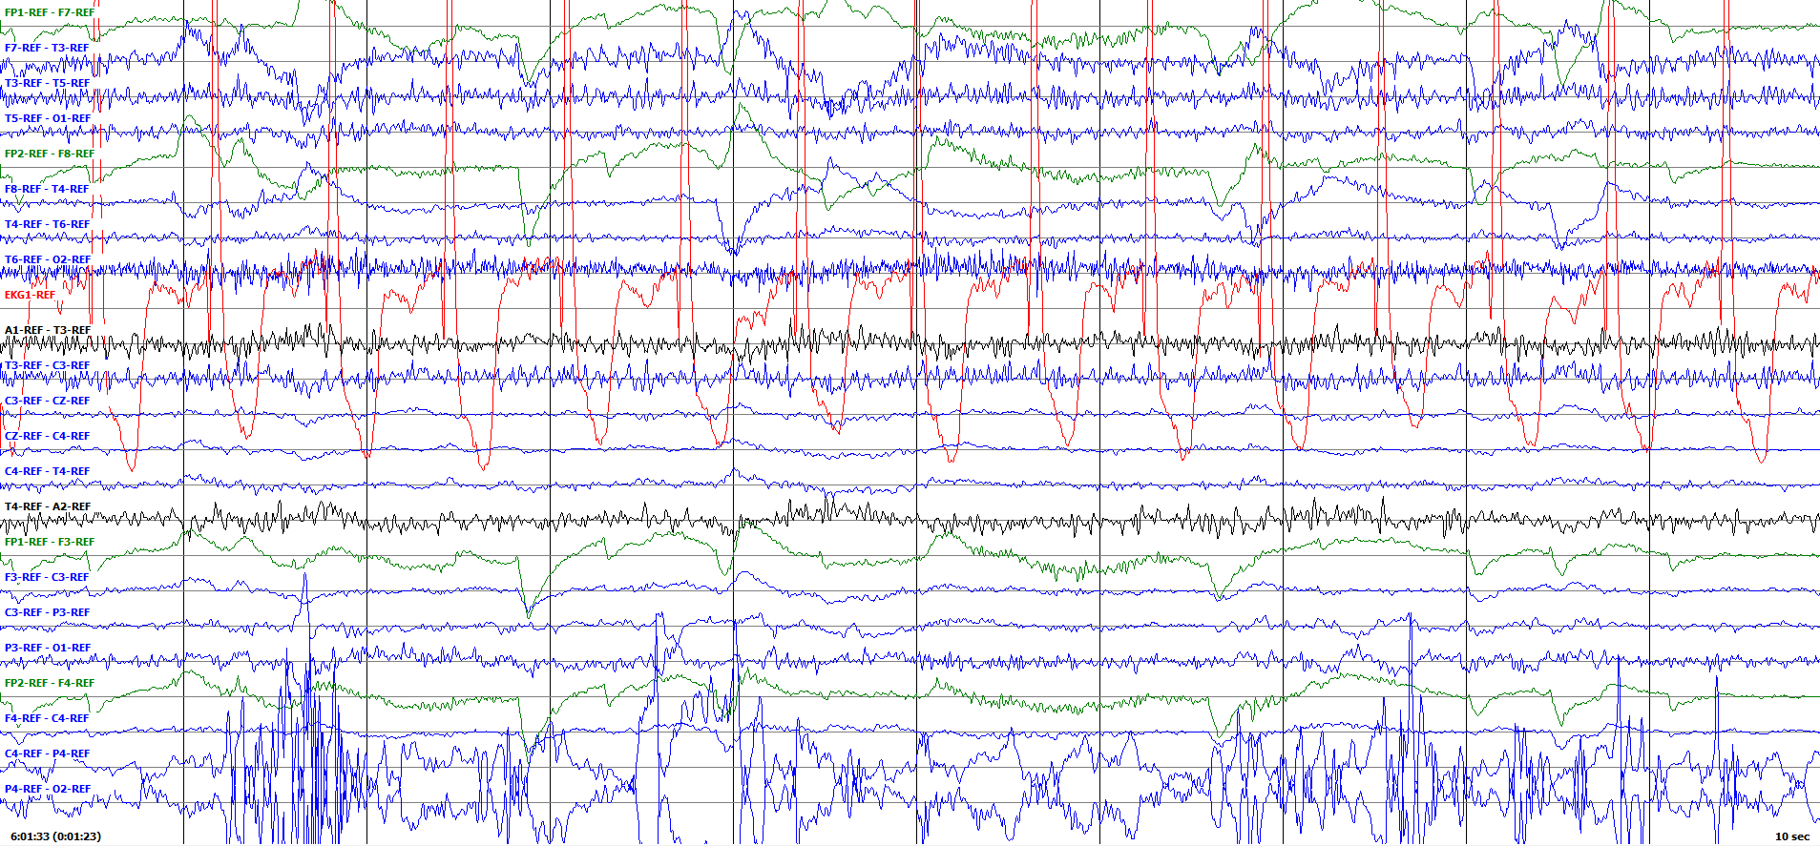

Figure 28. A series of electrode pops, obscuring the signal on two electrodes.

*Electrode Artifact (Tag: ELEC):* Electrode artifact is a catch-all annotation developed for the TUAR database. It encompasses three types of artifacts: electrode pop, electrostatic, and lead artifact. These artifacts are grouped together on the basis of their common origin.

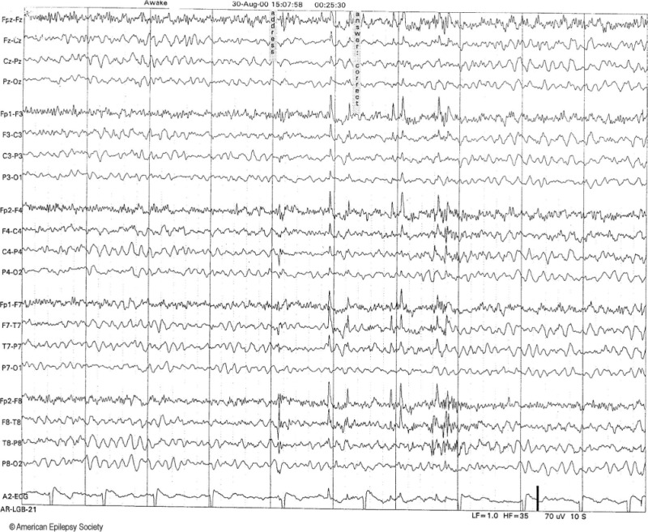

Figure 29. Dissimilar metals create an electrostatic discharge during talking. These discharges generate unipolar spikes in this epoch (Britton et al., 2016).

. 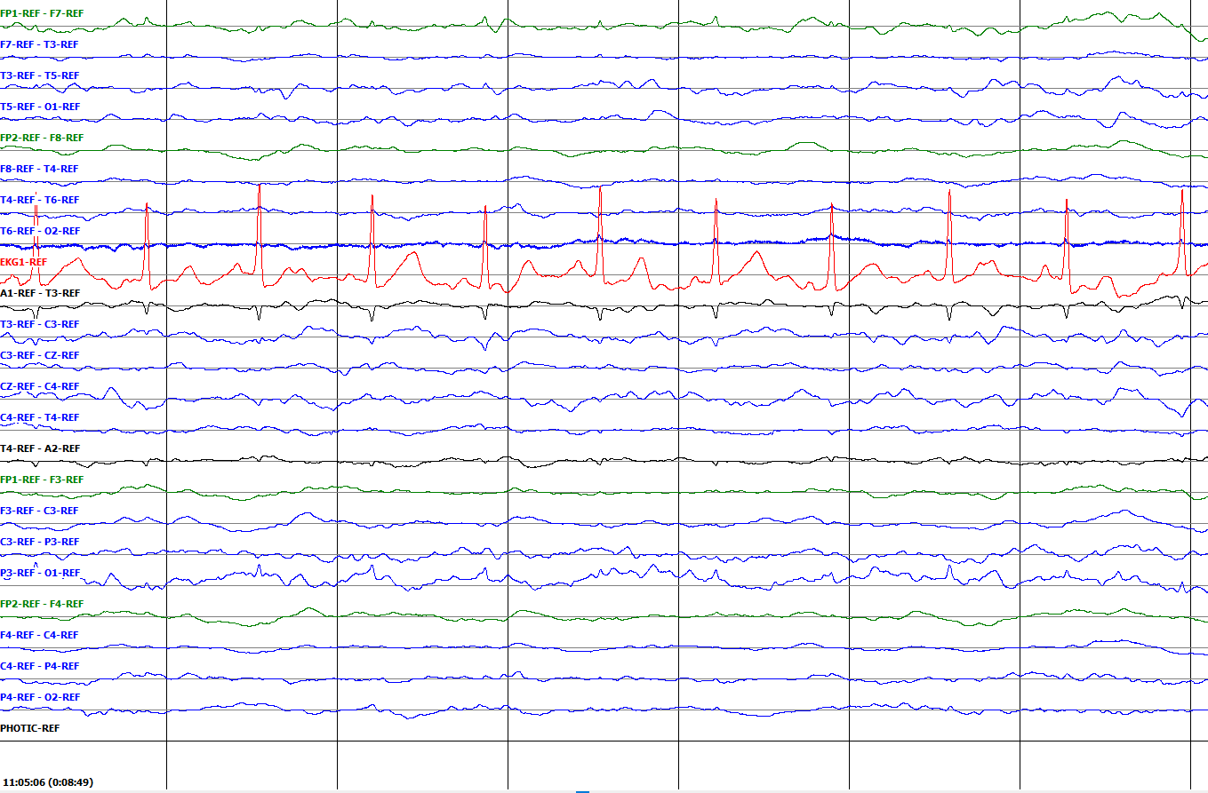

Figure 30. The display of an EKG artifact can bleed over into adjaent channels.

*Artifact Events (Untagged):* TUEG also contains several types of artifact events that we have elected not to annotate, as they do not yet seem to serve a significant purpose in the development of automated seizure detection technology. We have left placeholders for the use of tags that could enhance the information in our annotations. We started with a set of 9 tags, and as can be seen in Table 1, the list continues to grow.

Three common events that are not annotated are:

* *Electrocardiogram Artifact*: EKG artifact is not artifact on the EKG channel, but artifact that occurs in many channels. An EKG artifact results from the highly sensitive electrodes on the scalp picking up the changes in voltage associated with the beating heart. This artifact is usually low amplitude and is always temporally synced to the EKG channel. It occurs on all channels as a small sharp wave as seen in Figure 30.
* *Lead Artifact:* Lead artifact occurs from a poor connection or significant movement of the electrodes. This artifact produces disorganized, high amplitude slow waves as shown in Figure 31. The artifact will not resemble true cerebral activity and will usually occur on all channels associated with an individual electrode or several electrodes.
* *Jerk Artifact:* A jerk artifact is a form of muscle artifact that occurs from swift movements of the body. This artifact is closely associated with myoclonic seizures and consists of two spikes of opposite polarity coupled together. An example is shown in Figure 33. In some instances, many of these spikes can occur close together and may be indicative of a seizure, as was seen in Figure 18.

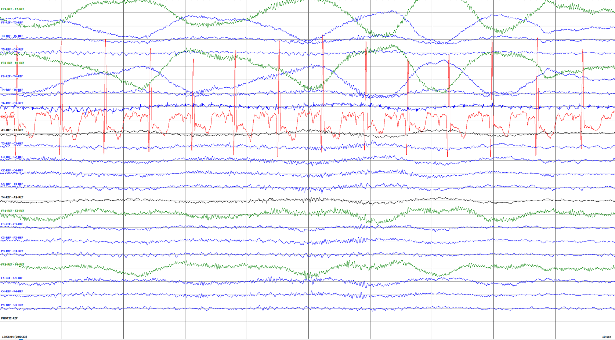

Figure 31. The disorganized signal produced from a lead artifact



Figure 32. A single electrode pop.



Figure 33. A series of electrode pops, obscured the signal on two electrodes.

* 1. **SLOWING EVENTS**

TUEG contains a subset of files with annotated slowing events. These particular events often use the tag SLOW and focus specifically on transient 0.5-7 Hz waves. However, slowing can be used much more broadly to describe smooth waves with delta, theta, and even alpha frequencies. These waves originate from many sources including sleep, dysfunction, and medication.

The TUEG annotations were expanded to include triphasic waves and hypnagogic hypersynchrony tags. These events carry their own distinct morphology from each other and from the typical transient slow waves focused on previously. It is hopeful that the inclusion of these slowing events will allow the construction of a system capable of reducing false alarm rates by understanding slowing morphology. Slowing is a very challenging problem for machine learning systems.

*Slow Waves (Tag: SLOW):* These waves are seen most commonly in drowsy or sleeping patients and are generally viewed as normal. Frequently, these waves also occur at the ends of seizures, during the postictal phase. They may also result from medication use or an underlying cerebral dysfunction. Although many types of waveforms may fall under the category of slowing, TUEG generally refers to slowing as smooth, low frequency (0.5-7 Hz) waves without the presence of sharps or spikes. An example is shown in Figure 34. They do not have any particular localization.

*Hypnagogic Hypersynchrony (Tag: HPHS):* Hypnagogic hypersynchrony events are generally seen as normal and occur in sleep, especially in children. An example is shown in Figure 32. They exhibit smooth, high amplitude waves in the frequency range of high delta through theta (3-8 Hz). These events are transient, usually lasting less than 10 seconds, and often have a generous spread, occurring on the majority of channels.

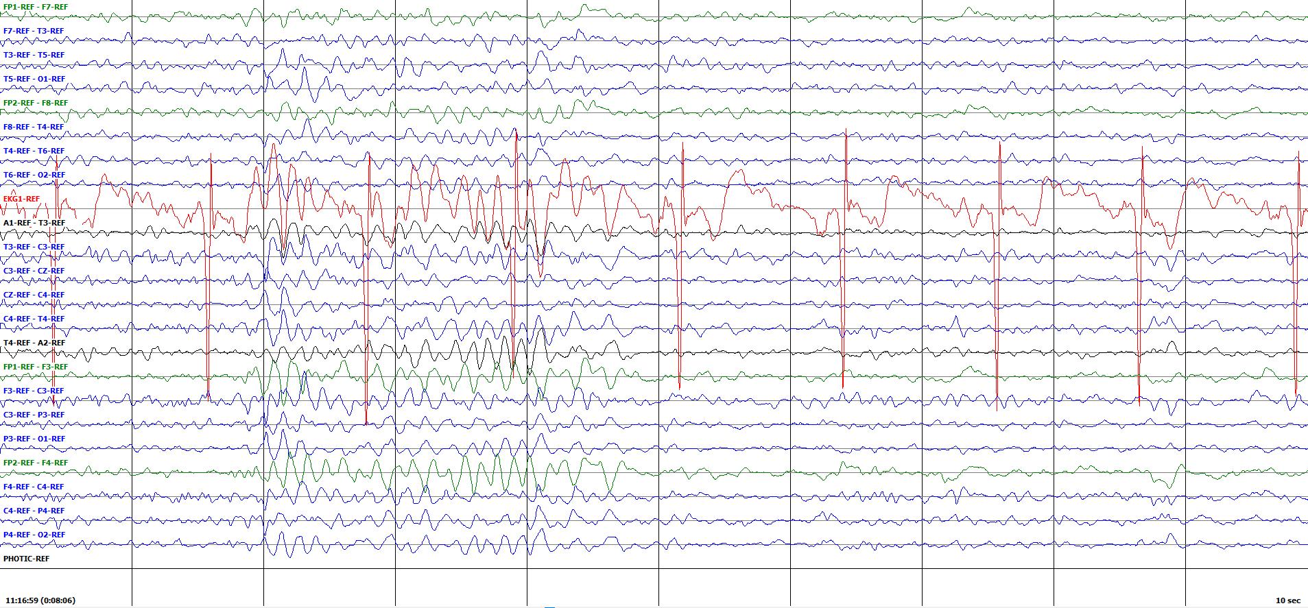

Figure 32. A hypnagogic hypersynchrony event

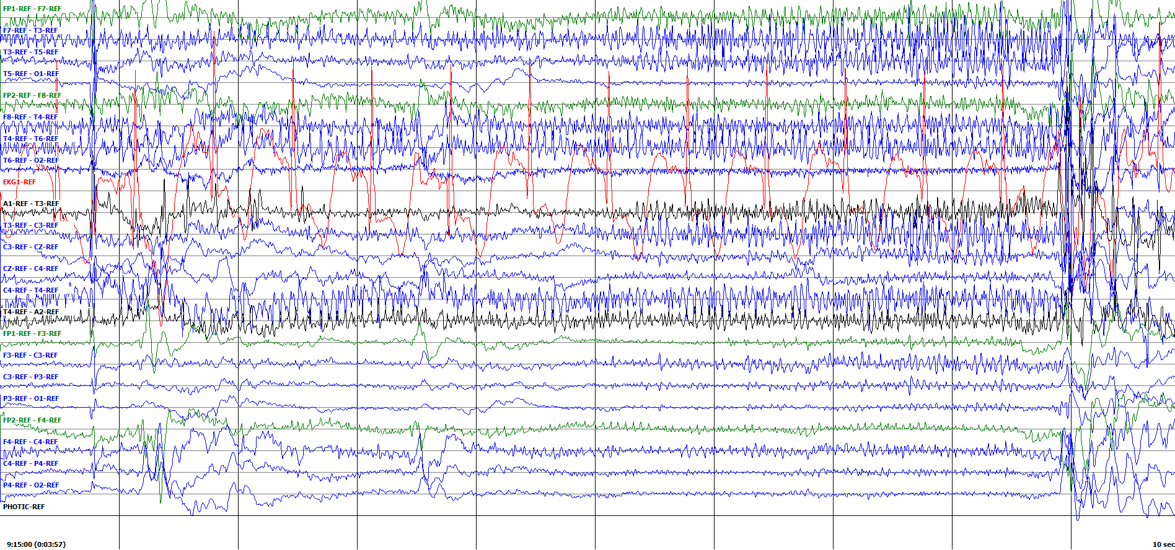

Figure 33. A single jerk artifact

Due to the high amplitude, frequency range, field of spread, and brief duration, Hypnagogic Hypersynchrony events are frequently mistaken for absence seizures. A comparison is shown in Figure 35. The key factor in discerning one from the other being the presence of spikes in absence seizures. These spikes are clearly missing in HPHS events.

*Triphasic Waves (Tag: TRIP):* Triphasic waves are a result of metabolic conditions that cause neurological dysfunction such as severe liver failure. The occurrence of these waves indicates a poor prognosis in these patients, though triphasic waves are not often used in differential diagnosis.

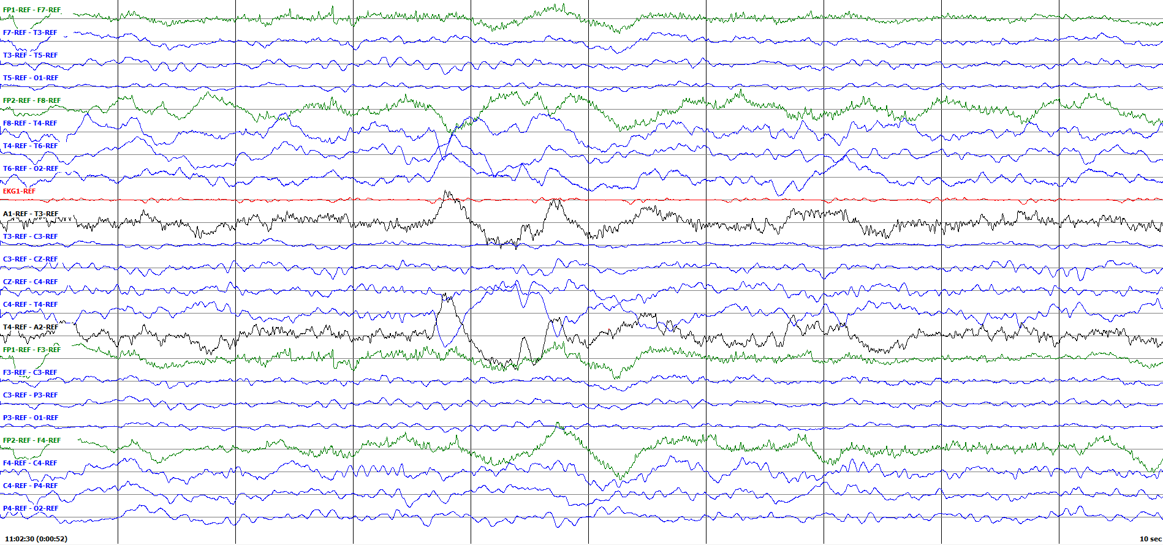

Figure 34. A series of slow waves

 

Figure 35. A side by side comparison of a hypnagogic hypersynchrony event (HPHS) from Figure 33 (left) and an absence seizure event (ABSZ) from Figure 19 (right). Note the smooth, high amplitude waves present in HPHS versus the complexes of well‑defined spikes (arrows) in ABSZ.

These waves occur at a frequency of 1-3 Hz with a distinct, highly misleading morphology. The three phases of a triphasic wave are first a sharp, followed directly by a sharp of opposite polarity, then another sharp of the same polarity of the first. An example is shown in Figure 36. These complexes are separated by short attenuations in the signal. Triphasic waves frequently occur in long runs and may even seem to show evolution, going from a low to high amplitude signal. The waves may occur focally and be spatially confined to as little as a single electrode or their occurrence may be generalized and occur across all channels simultaneously.

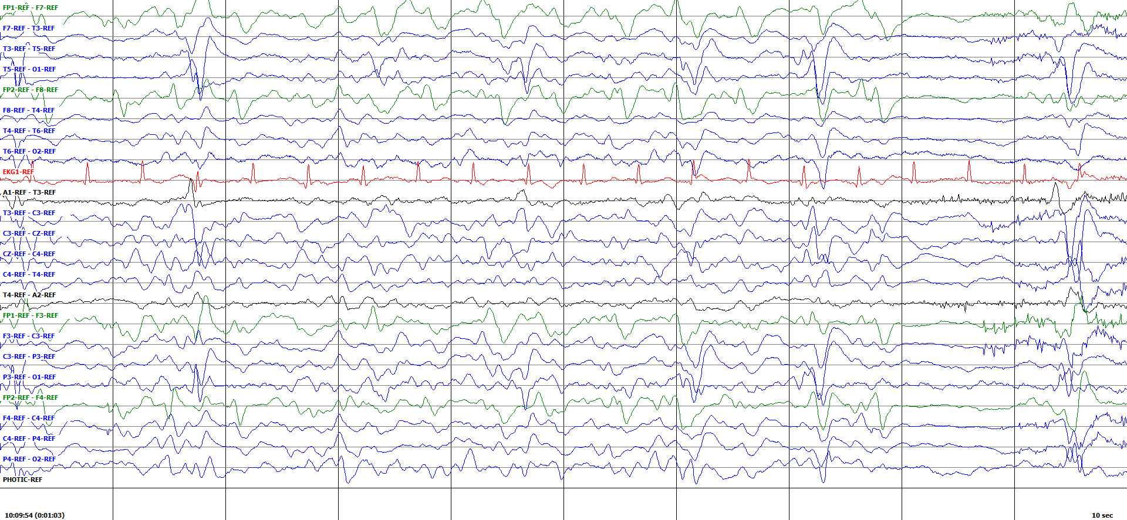



Figure 36. A series of focal triphasic waves that demonstrate the three phases that compose the triphasic wave

The morphology of triphasic waves is incredibly close to that of the spike and slow wave complexes seen in seizures. This causes triphasic waves to be a common source of error in both hand-annotated events and automated seizure detection. In order to distinguish between a triphasic wave and a spike and slow wave, one must look for the baseline present in the triphasic wave. This is demonstrated in Figure 37. These portions of baseline, the lack of evolution, and the slower frequency are the key characteristics in distinguishing triphasic waves from seizure.

 

Figure 37. A side by side comparison of triphasic waves (TRIP) from Figure 36 (left) and a focal seizure (SPSZ) from Figure 10 (right). Here we can see the presence of baseline that differentiates triphasic waves from seizures. It is also easy to note that this particular seizure occurs at a higher frequency than the TRIP event. While this is frequently the case, it is not necessarily the rule.

Clinical data is also highly relevant in distinguishing between triphasic waves and seizure. If the report indicates the patient has a metabolic disorder, it is best to approach all events with a sense of skepticism. Annotators must be sure the event has the proper morphology, evolution, and frequency range to be a seizure.

* 1. **ICTAL EVENTS**

In TUEG, some events are considered ictal, but are not themselves seizure events. They are indicative of neurological dysfunction and are closely related to seizures, but they themselves are unable to constitute seizures. We annotate a subset of these types of events because we find them useful in the development of machine learning technology.

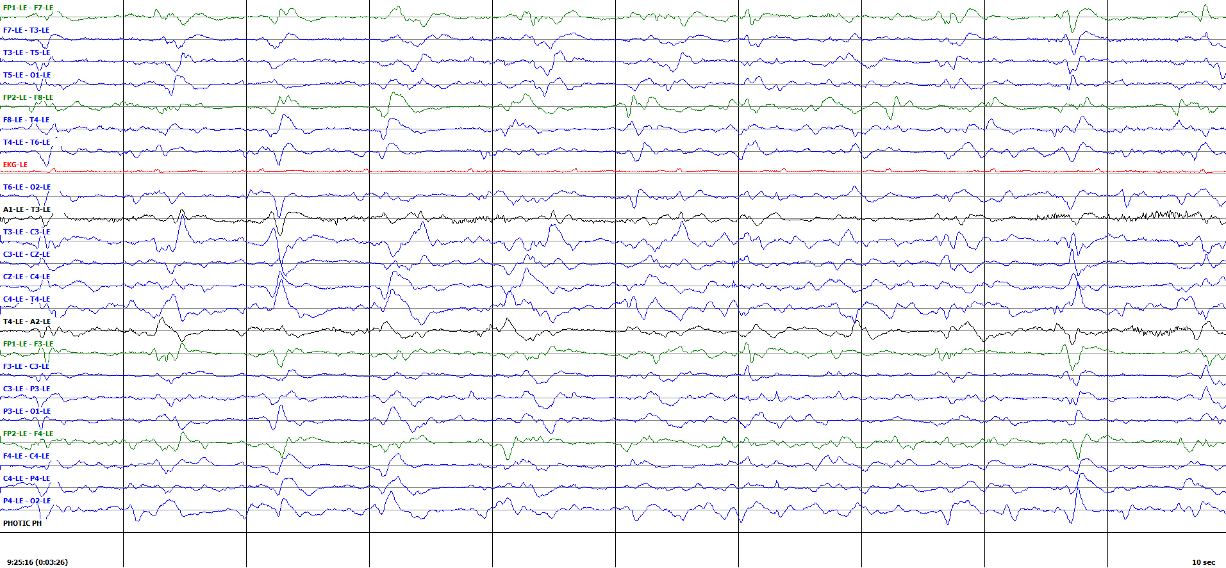

Figure 38. A single GPED occurring in a cardiac arrest victim

*Generalized Periodic Epileptiform Discharges (Tag: GPED):* These events are ictal discharges that are highly indicative of neurological dysfunction. The number of GPEDs in a record is positively correlated with seizure probability and poor clinical outcomes for patients who have experienced anoxic/hypoxic events, such as drowning or cardiac arrest. In severe cases of anoxic/hypoxic brain damage, the record may consist entirely of GPEDs.

Although the morphology of GPEDs has some variety, a few things are consistent. GPEDs are less than 0.5 seconds in length or have less than three phases. These phases consist of sharp waves that reverse in polarity and then return to baseline. An example is shown in Figure 38. In order for a discharge to be a GPED, it must occur on all channels simultaneously. In some instances, GPEDs will occur in rapid succession, such as the example shown in Figure 39. This type of event may give the impression of a seizure. However, in TUEG this is not considered to be a seizure event.

*Periodic Lateralized Epileptiform Discharge (Tag: PLED):* These events are identical to GPEDs, only they occur in one spatially confined portion of the brain. They follow the same morphology of GPED’s and are present in the same conditions. An example is shown in Figure 40.

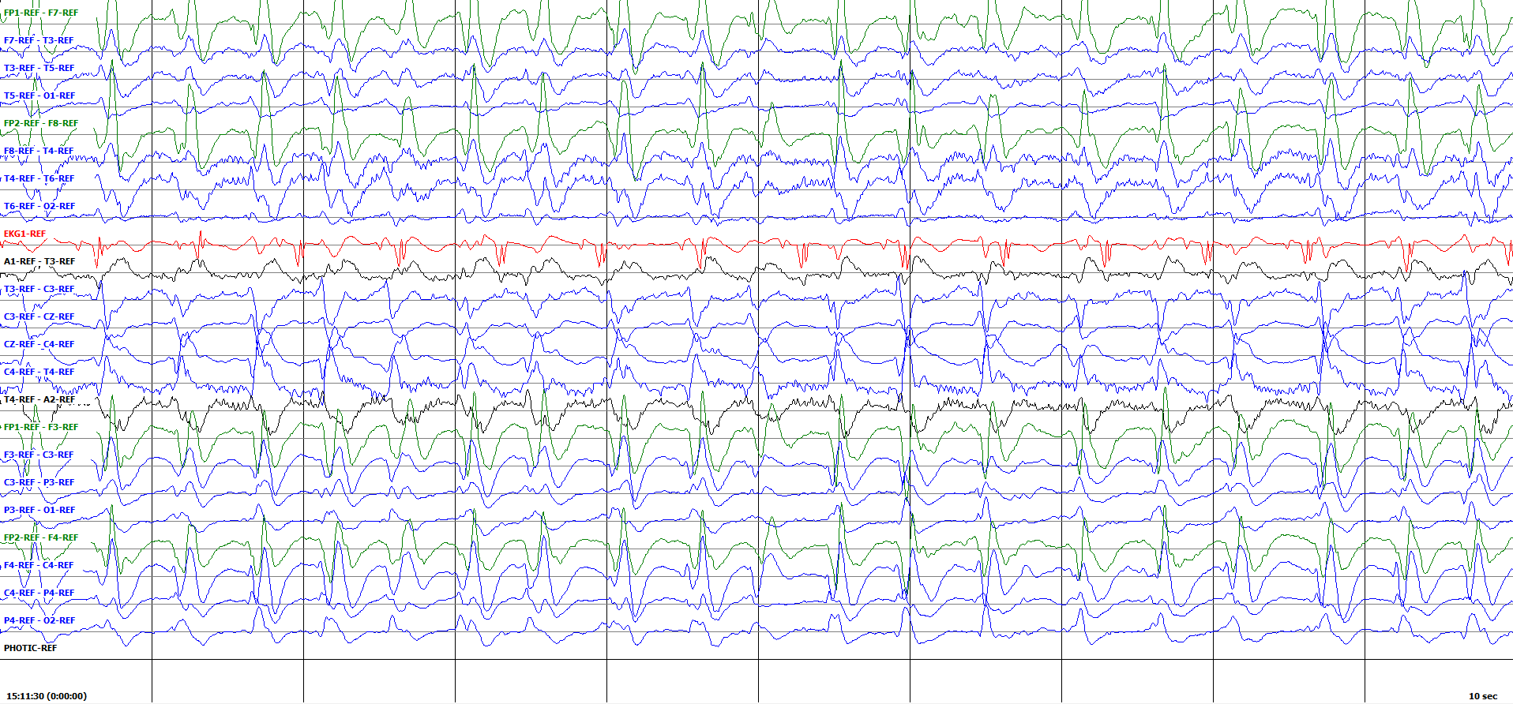

Figure 39. A GPED run indicating a poor prognosis in a patient following cardiac arrest and subsequent resuscitation

Ictal events that are not explicitly tagged include:

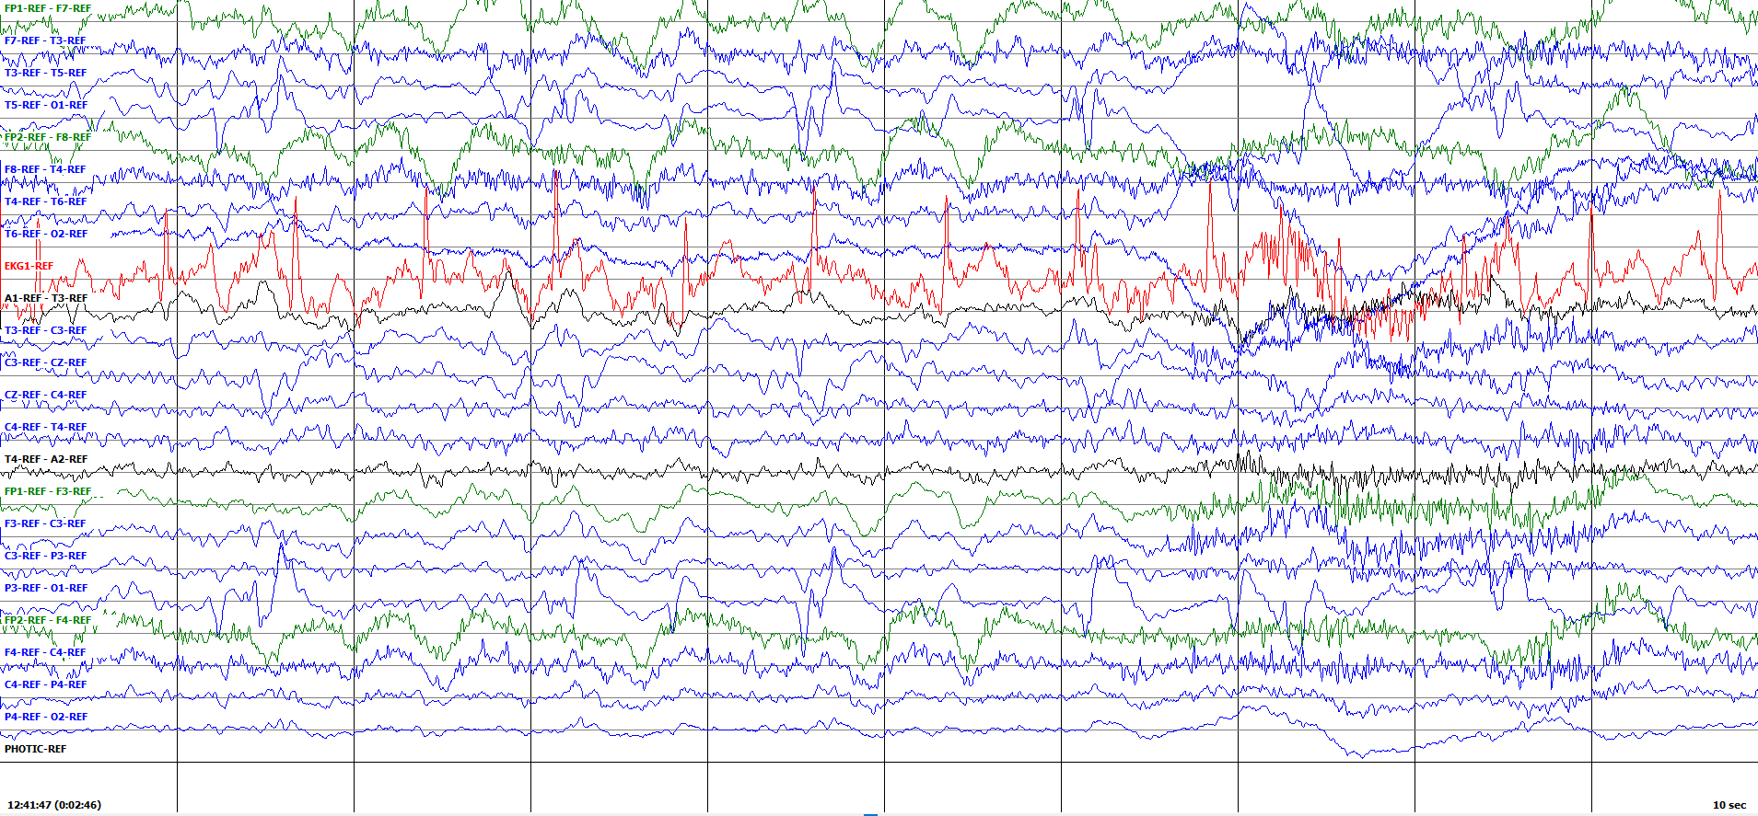

Figure 40. A single PLED originating on the left occipital

* *Spike:* Spikes are very fast waves (less than 80 milliseconds) that are usually included in the discussion due to their relevance in spike and wave complexes. Figure 41 shows a series of spikes, where Figure 42 shows a series of polyspikes, which are a complex formed by rapid, sequential spikes. On their own, spikes do not constitute seizures. However, they are key morphological features in many ictal complexes.

The presence of spikes in an EEG record may indicate neurological dysfunction. However, this should not be weighted too heavily, as they also occur in normal EEG records for a variety of reasons, including as artifacts.

* *Sharp:* Sharp waves, often referred to as sharps, are typically 80-200 ms in duration. An example is shown in Figure 43. Similar to spikes, sharps are key morphological features in many complexes. Sharps may indicate the presence of neurological dysfunction, but do not constitute seizure events themselves. Sharps do occur in the normal EEG but are more common in patients with epilepsy.

Non-ictal cerebral events that are not tagged include:

* *Breach Rhythm:* Breach rhythm occurs when a portion of the skull is not present. Where the skull is not present, unimpeded electrical signals from the brain are able to reach the surface of the scalp and result in a chaotic higher amplitude and frequency baseline with spike and sharp waves. An example is shown in Figure 44. This activity is limited to the electrodes that are over the missing portion of the skull. Clinical data is useful for determining when a breach rhythm is present, though it is often not needed due the distinct morphology of the signal.
* *Burst Suppression:* Burst suppression results from an inability to regulate calcium levels in the brain, which may be due to either pathology or medications. In burst suppression, there are brief periods of moderate to high amplitude activity, usually involving spikes and sharps, followed by an attenuation of the signal. The suppression portion usually occurs on all channels simultaneously, though it may be more apparent on channels with greater activity. Burst suppression can occur during a seizure, as shown in Figure 45. In this case we observe periods of an attenuated signal intermixed with myoclonic spiking. In these instances, the periods of activity should show spike and slow wave morphology, reflecting the presence of an underlying seizure event.

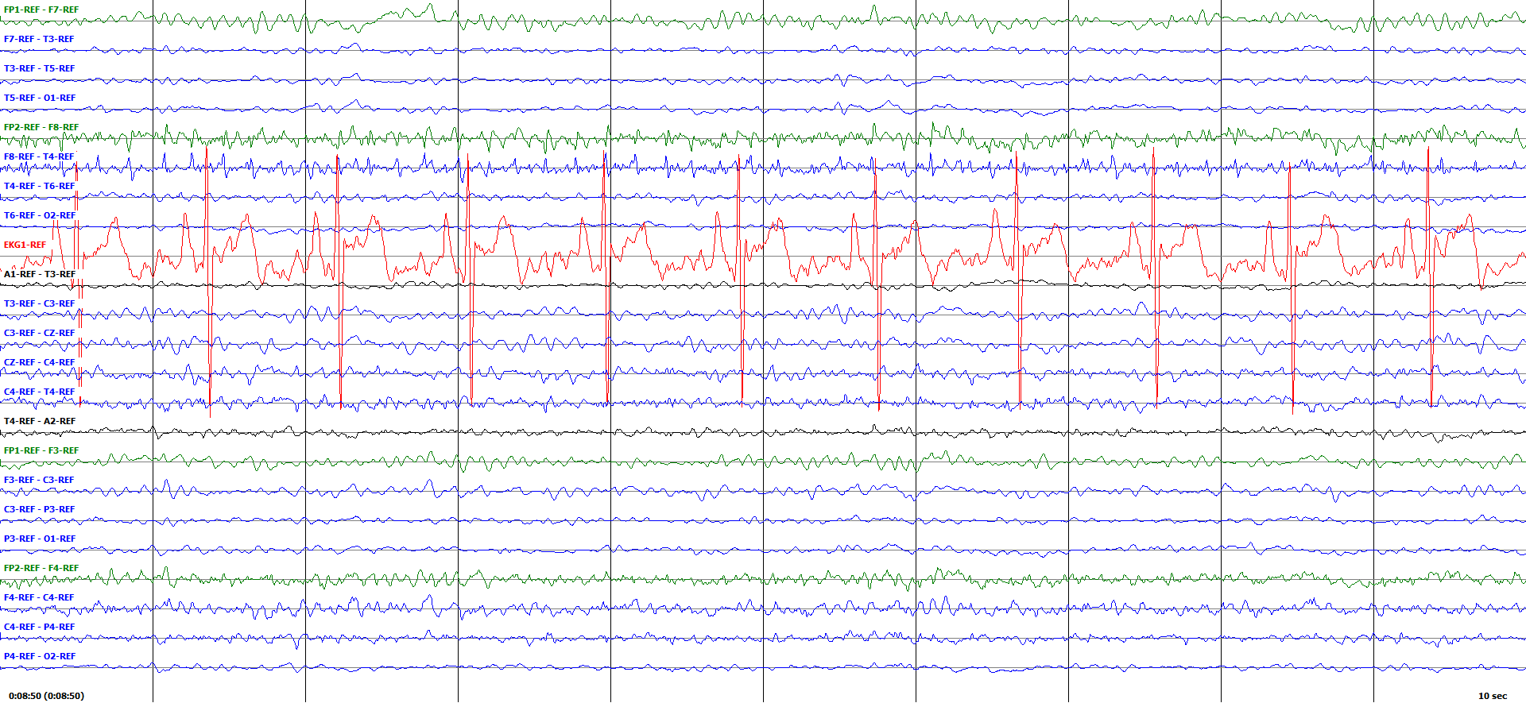

Figure 41. A series of spikes

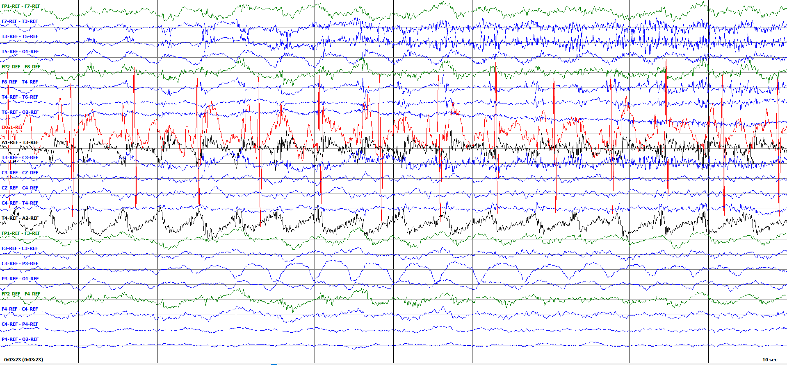

Figure 42. A series of polyspikes building in amplitude

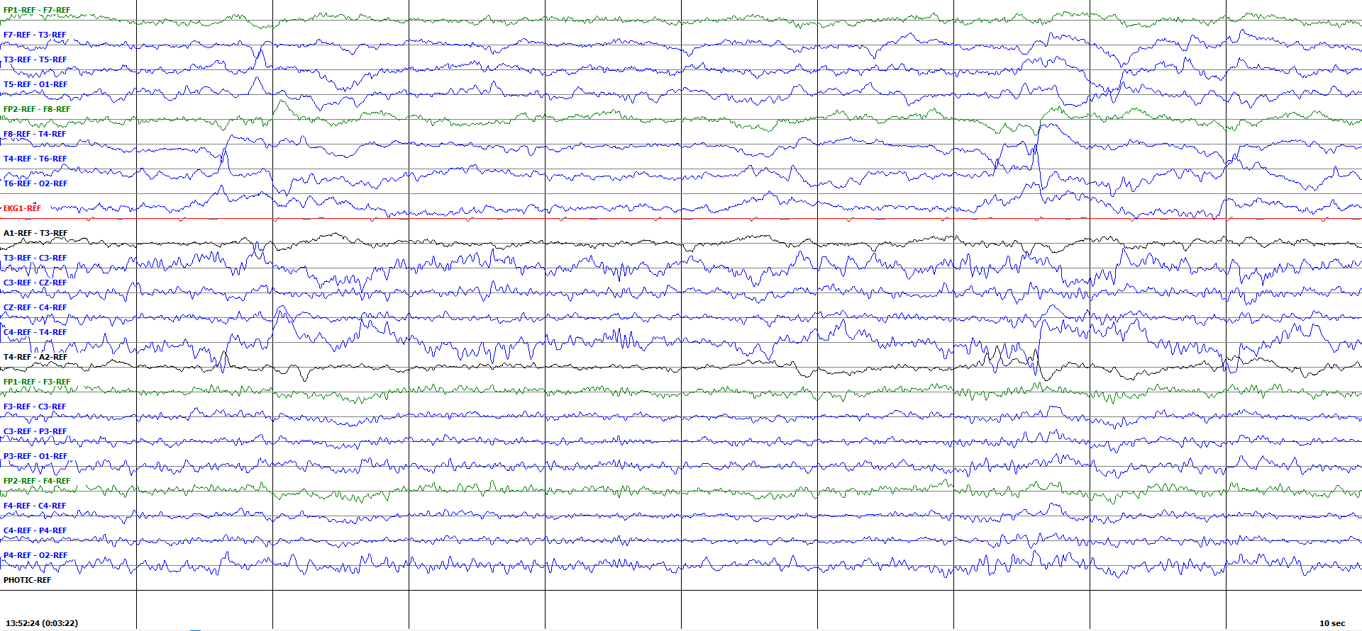

Figure 43. A moderate amplitude sharp wave in a patient with prominent epileptiform activity from the right temporal (T4 + T6)

These events are often seen as correlates to underlying physiological or neurological conditions. The occurrence of these signals gives an indication of the neurological condition of the patient. Their presence, though not indicative of a current seizure, increases clinical suspicion of the occurrence of a previous or future seizure. These signals can also be used in discerning the prognosis of many neurological and physiological conditions. It is possible we will decide to tag some of these events in the future as our development of high-performance machine learning technology improves. However, currently, we have not been able to successfully leverage such annotations.





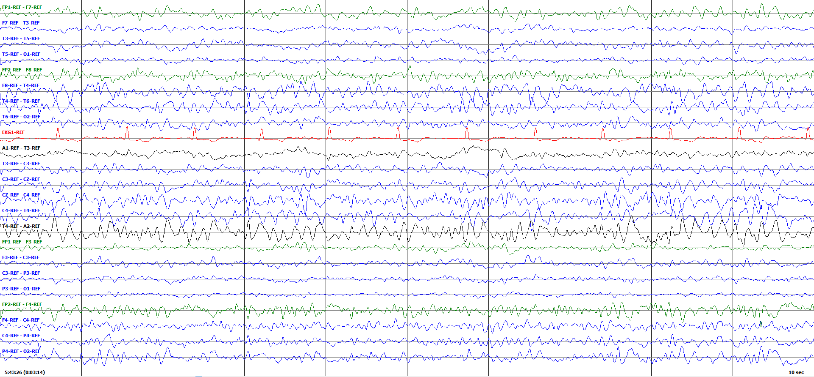

Figure 44. A breach rhythm occurring on the T4 electrode in a patient with a right temporal craniotomy and subdural hematoma



Figure 45. Burst suppression during status epilepticus in a patient with an anoxic brain injury

1. **SUMMARY**

Large open source corpora with manual annotations of the data are the foundations upon which modern machine learning technology is developed. In this document, we have described the file formats used to store our annotations. Two formats have been presented: a label file (*.lbl) that represents an annotation as a hierarchical graph, and a time-synchronous event file (*.tse) that represents a flat annotation that represents a series of sequential events using start and stop times, type of seizure, and probability. In the near future, these formats will be replaced by a single XML format that will simplify the process of reading and writing annotation files in Python.

In this document we also described the four different types of annotations that we provide. We use one of two formats: (1) *event-based:* annotations of start time, stop time, and seizure type on a specific channel; (2) *term-based:* all channels share the same annotation, which is an aggregation of the per-channel annotations. There are also two classes of annotations that are useful for machine learning research: (1) *multi-class:* annotations that provide users with the specific type of seizure event; (2) *bi-class:* simply describe whether or not a seizure has occurred.

This document describes the format of this data so that programmers can develop software to manipulate these files. Example programs manipulating these files are available from our project web site. NEDC has released a number of valuable annotated corpora involving clinical EEG data. These corpora and associated resources are available from the following URL on our project web site: *https://www.isip.piconepress.com/projects/tuh_eeg/downloads*. To register to access these resources, please complete our registration form located as this URL:

*https://www.isip.piconepress.com/projects/tuh_eeg/html/request_access.php*

The process is completely automated.

This document also includes a description of the methodologies we have used to tag events. We presented a list of all events that are currently being tagged and provided examples of these events from actual clinical data. This document is not meant to replace more comprehensive textbooks on the subject, but rather are intended to be a starting point for scientists who desire to understand how EEG signals are annotated. Textbooks such as Britton et al. (2016) are excellent resources for those who want to better understand the interpretation of EEG signals.

**Acknowledgements**

Research reported in this publication was most recently supported by the National Science Foundation Partnership for Innovation award number IIP-1827565 and the Pennsylvania Commonwealth Universal Research Enhancement Program (PA CURE).

Several grants over the years have supported this database development project. Significant contributors include National Human Genome Research Institute of the National Institutes of Health award number U01HG008468, DARPA Microsystems Technology Office award number D13AP00065, National Science Foundation Division of Computer and Network Systems award number CNS-1305190, the Temple University Office of the Vice-Provost for Research and the Temple University College of Engineering.

Any opinions, findings, and conclusions or recommendations expressed in this material are those of the author(s) and do not necessarily reflect the official views of any of these organizations.

**REFERENCES**

Beelen, T. van. (2013). EDFbrowser. *http://www.teuniz.net/edfbrowser/*.

Britton, J. W., Frey, L. C., Hopp, J. L., Korb, P., Koubeissi, M., Lievens, W., … St. Louis, E. K. (2016). *Electroencephalography (EEG): An Introductory Text and Atlas of Normal and Abnormal Findings in Adults, Children, and Infants* [Internet]. In E. K. St. Louis & L. C. Frey (Eds.), American Epilepsy Society (1st ed.). *https://www.ncbi.nlm.nih.gov/books/NBK390352/*.

Capp, N., Campbell, C., Elseify, T., Obeid, I., & Picone, J. (2018). Optimizing EEG Visualization Through Remote Data Retrieval. *Proceedings of the IEEE Signal Processing in Medicine and Biology Symposium* (pp. 1–2). Philadelphia, Pennsylvania, USA. *https://doi.org/10.1109/SPMB.2018.8615613*.

Capp, N., Krome, E., Obeid, I., & Picone, J. (2017). Facilitating the annotation of seizure events through an extensible visualization tool. In I. Obeid & J. Picone (Eds.), *IEEE Signal Processing in Medicine and Biology Symposium* (p. 1). Philadelphia, Pennsylvania, USA: IEEE. *https://doi.org/10.1109/SPMB.2017.8257043*.

Choi, S. I., Lopez, S., Obeid, I., Jacobson, M., & Picone, J. (2017). The Temple University Hospital EEG Corpus. *https://doi.org/http://www.isip.piconepress.com/projects/tuh_eeg*.

Ferrell, S., Mathew, V., Ahsan, T., & Picone, J. (2019). *The Temple University Hospital EEG Corpus: Electrode Location and Channel Labels*. Philadelphia, Pennsylvania, USA. *https://www.isip.piconepress.com/publications/reports/2019/tuh_eeg/electrodes*.

Golmohammadi, M., Harati Nejad Torbati, A. H., de Diego, S., Obeid, I., & Picone, J. (2019). Automatic Analysis of EEGs Using Big Data and Hybrid Deep Learning Architectures. *Frontiers in Human Neuroscience*, *13*, 76. *https://doi.org/10.3389/fnhum.2019.00076*.

Harati, A., Choi, S. I., Tabrizi, M., Obeid, I., Jacobson, M., & Picone, J. (2013). The Temple University Hospital EEG Corpus. In *Proceedings of the IEEE Global Conference on Signal and Information Processing* (pp. 29–32). Austin, Texas, USA. *http://www.isip.piconepress.com/publications/conference_proceedings/2013/ieee_globalsip*.

McHugh, J. R., & Picone, J. (2016). A Software Tool to Print Labels. Retrieved August 13, 2018, from *https://www.isip.piconepress.com/projects/tuh_eeg/downloads/tuh_eeg/tools/ nedc_print_labels/*.

Obeid, I., & Picone, J. (2016). The Temple University Hospital EEG Data Corpus. In M. A. Lebedev (Ed.), *Augmentation of Brain Function: Facts, Fiction and Controversy. Volume I: Brain-Machine Interfaces* (1st ed., Vol. 10, pp. 394–398). Lausanne, Switzerland: Frontiers Media S.A. *https://doi.org/10.3389/fnins.2016.00196*.

Shah, V., von Weltin, E., Ahsan, T., Obeid, I., & Picone, J. (2019). On the Use of Non-Experts for Generation of High-Quality Annotations of Seizure Events. *Journal of Clinical Neurophysiology*. *https://www.isip.piconepress.com/publications/unpublished/journals/2020/elsevier_cn/ira/*.

Veloso, L., McHugh, J. R., von Weltin, E., Obeid, I., & Picone, J. (2017). Big Data Resources for EEGs: Enabling Deep Learning Research. In I. Obeid & J. Picone (Eds.), *Proceedings of the IEEE Signal Processing in Medicine and Biology Symposium* (p. 1). Philadelphia, Pennsylvania, USA: IEEE. *https://doi.org/10.1109/SPMB.2017.8257044*.

von Weltin, E., Ahsan, T., Shah, V., Jamshed, D., Golmohammadi, M., Obeid, I., & Picone, J. (2017). Electroencephalographic Slowing: A Primary Source of Error in Automatic Seizure Detection. In I. Obeid & J. Picone (Eds.), *Proceedings of the IEEE Signal Processing in Medicine and Biology Symposium* (pp. 1–5). Philadelphia, Pennsylvania, USA: IEEE. *https://doi.org/10.1109/SPMB.2017.8257018.*